Lesson Plan: Stem & Leaf
Lesson Overview
Description | Using real‑world pricing data to compare candy costs across two stores using back‑to‑back stem‑and‑leaf plots and data science practices.
Subject Area(s) | Mathematics
Grade Band(s) | 6-8

Learning Progression Alignment
Strand | Strand C — Analysis and Modeling Techniques
Substrand | Substrand C.2. — Identifying Patterns and Relationships in Data  Substrand C.3. — Variability in Data
Concept | Concept C.2.2 — Understanding distributions — Represent data visually and numerically to describe how outcomes occur and compare groups. Use variability to interpret distribution shape, support statistical reasoning, and assess population estimates.  - 6-8.C.2.2a: Represent the variability of numerical variables using appropriate displays (e.g., dotplots, boxplots).  Concept C.3.2 — Comparing variability — Examine differences between groups by analyzing measures of spread, such as range and standard deviation. Utilize visualizations like box plots and apply statistical methods, including mean, median, and standard deviation, to compare datasets, assess variability, and uncover patterns in data distributions and models.  - 6-8.C.3.2a: Use visualizations (e.g., box plots) to compare variability across datasets.

Tool(s)
Type | n/a
Tool | Internet
Programming Language | n/a
Other Tech Notes | n/a

Lesson Materials
Dataset | n/a
Datasheet | n/a
Student Document(s) & File(s) | Student WS Stem and Leaf  candy_prices  Candy Prices (Student) CODAP
Teacher Document(s) & File(s) | Teacher WS Stem and Leaf  ​​candy_prices  CVS Candy Prices are INSANE! You Won't Believe This! #shorts  Candy Prices (Teacher) CODAP
Lesson Plan Template 1
Lesson Plan
Lesson Focus | Using real‑world candy pricing data to compare two stores by organizing prices (rounded to one decimal) in a back‑to‑back stem‑and‑leaf plot and making data‑driven conclusions.  Please note: This lesson builds from students’ prior understanding of ordering numbers and single‑dataset stem‑and‑leaf plots toward comparative data analysis. Students advance from creating displays to interpreting variability and using statistical evidence to justify conclusions, preparing them for histograms, box plots, and bivariate data comparisons in later grades.
Content Objective(s) | Students will:  - Analyze real‑world data from online sources  - Apply rules to clean and standardize data  - Organize price data into a stem‑and‑leaf plot  - Analyze distribution, median, range, clusters, and outliers  - Experience how data scientists turn messy data into usable information to make decisions
Prerequisite Knowledge & Skills | - Rounding decimals to the nearest tenth  - Ordering decimals  - Understanding of place value (ones and tenths)  - Introductory familiarity with stem‑and‑leaf plots  - Understanding of median and range
Lesson Details
Lesson Hook & Warm-up  10 mins | STUDENT FACING  “Where do you think the best place is to buy candy?”  Examples: Amazon, Walmart, Target, CVS, Walgreens  As a class, vote on the top two stores students believe have the best prices.  Predict: Which store will be cheaper overall? Why do you think that?
TEACHER FACING

- Have students justify what types of considerations they made to determine what “best” means to them (e.g., price, selection, etc.)? Then guide them towards choosing retailers they think fit their criteria.
- Guide the class to select two stores from the candy_prices file.
  - You might want to have several store options that are commonly used in your area and have students vote by hand raising. Or you can call on a few students to ask which store they would pick, pausing to ask, “does anyone else agree?” and if the majority of the students agree, then jot it down as an option. Collect five in such a way, and then have students vote on those five.
- Emphasize that predictions will later be checked against data.
Expected Responses:
- Students may predict either store.
- Reasoning often includes:
  - “Amazon is cheaper because it sells online”
  - “Walmart has lower prices”
  - “Drugstores are usually more expensive”
Acceptable as long as a reason is given.
Activity 1:  Collecting Data  15 mins | STUDENT FACING  You and your partner will choose two retailers and one type of candy (e.g., CVS, Target and chocolate)  Step 1: Choose your combination  Choose one combination of candy characteristics to investigate. As a class, try to select different combinations so that we cover as many combinations as possible. We’ll list them on the board.  Candy Type:  Store 1:  Store 2:  Step 2: Identify matching rows  Identify the rows that match your candy type.  Step 3: Record candy prices
  Candy Name | Candy Type | Price at Store 1 | Price at Store 2
TEACHER FACING

Make sure the students select different combinations and record them on the board. They may notice that some candies fall into more than one type. Let them know for now, this is ok because the goal is to analyze pricing across stores.
Ask before data recording:
“What guardrails should we use so our comparison is fair and consistent?”
- Allow students to think about ways to record the prices and try to guide them towards rounding.
- Prices rounded to one decimal places are recommended to make the Stem and Leaf easier to navigate and to avoid mistakes, such as writing $2.09 as 2|9 instead of 2|09
Ideas to share with students:
- “Sometimes data scientists have to filter data before they can analyze it. These rules help identify patterns for groups that are the same (e.g., chocolate) and compare across different groups (e.g., different retailers).”
- Explain why students listed what combination they are investigating: “Explain that different partners will research different candies so the class gets a broad, useful understanding of the data.”

Record candy prices
Ask before data recording: “What guardrails should we use so our comparison is fair and consistent?”
- Allow students to think about ways to record the prices and try to guide them towards rounding.
- Prices rounded to one decimal places are recommended to make the Stem and Leaf easier to navigate and to avoid mistakes, such as writing $2.09 as 2|9 instead of 2|09
- Note: Students can record data on a separate sheet or in spreadsheet software.
Activity 2:  Graphing  20 mins | STUDENT FACING  Analyze and Summarize Your Data  - Sort the prices from each store from least to greatest.  - Compute the average price using all the prices. What would this value represent?  - Complete the table  - Use the table to summarize and compare the subset dataset to the full dataset.  Organize Your Data in a Sem-and-Leaf Plot  - What are some advantages of using a stem-and-leaf plot instead of a histogram for your subset of data?  - Organize your data in a back-to-back stem-and-leaf plot
TEACHER FACING

- Emphasize the advantages of using a stem-and-leaf plot
- Model how to place one price (e.g., 4.7 → 4 | 7).
- Emphasize ordering leaves correctly on both sides.
- Highlight how the back‑to‑back plot allows direct comparison between stores.
Correct structure:
- Stem = whole dollar value
- Leaf = tenths digit
Example:
- 4.7 → 4 | 7
- 5.0 → 5 | 0
Common mistake:
- Using tenths as stem (e.g., 47 as a number)
Circulate and make sure each graph has
Both stores clearly labeled
Stems in the center
Leaves ordered numerically
Key included (e.g., 4 | 7 = $4.7)
Example structure (values will vary):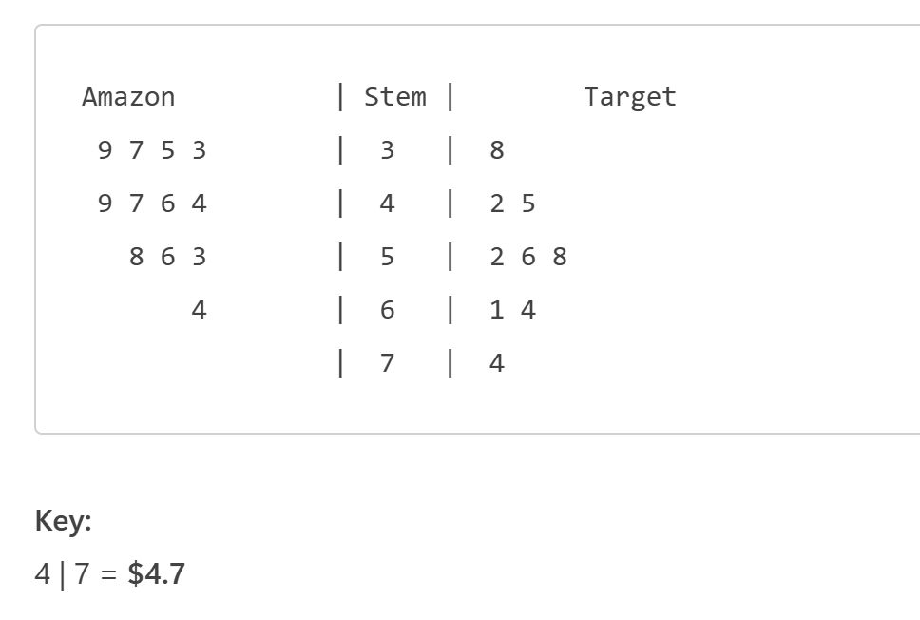
- Which store has more prices in the lower dollar ranges?
- Which store has the lower median price?
- Are there any outliers? If yes, what might explain them?
Lesson Synthesis  10 mins | STUDENT FACING  Discuss as a class:  - Which store appears to have better candy prices overall?  - What evidence from the stem‑and‑leaf plot supports your conclusion?  - Would the median or range be more helpful here? Why?  - Are there any limitations to our data when drawing a conclusion?  Final Conclusion  - Which store would you recommend for buying candy?  - Explain your reasoning using evidence from the data:
TEACHER FACING
- Lead discussion connecting visual patterns to conclusions.
- Emphasize that claims must be supported by data.
- Connect this process to real‑world decision‑making (shopping, budgeting, business pricing).
- Limitations might include: did not account for sales on candy, VIP cards, how convenient the store is (factoring in gas price to get there).

Final Conclusion
- Which store would you recommend for buying candy?
- Explain your reasoning using evidence from the data.
Closing Activity  5 mins | STUDENT FACING  Exit Ticket:  The back‑to‑back stem‑and‑leaf plot helped me see…
TEACHER FACING
Accept any thoughtful completion of:
- How the stem‑and‑leaf helped
Look for:
- Understanding of visualization
- Awareness of data cleanliness
Optional Add-on:
- Look at the video CVS Candy Prices are INSANE! You Won't Believe This! #shorts and discuss whether or not the claims made by the influencer are supported by the class analysis.
- Explore the Candy Prices (Student) CODAP file to look at the dot plots of prices between the stores
Student Follow Up & Practice | Student Follow‑Up & Practice  - Create a histogram using the same data  - Write a short paragraph explaining whether a different visualization might be better  - Optional extension: Compare three stores using discussion only
References

