Activity 1: What does it mean to have a home court advantage?
The data set below has statistics for the teams competing in the 2025-2026 NCAA basketball season.Use it to explore if there is a homecourt advantage. Be sure to justify your answer using graphs and statistics.
Basketball Data

- Can we begin to quantify what a home court advantage might be? For games played at home, is there a way we can create a new variable that combines information from both graphs into a single value?

- What do you predict the distribution of this variable will look like? Will the distribution be centered above 0, below 0, or around 0? Why?

- Create the distribution of the difference. Were you correct? If not, Can you explain why any of your predictions were not accurate.

- How can we use the distribution of the differences to describe a teams homecourt advantage?

- What does a positive value indicate?

- What does a negative value indicate?

- What does zero indicate?

- How does the size of the number impact the interpretation?

Activity 2

Let’s consider the NCAA tournament, better known as March Madness. For this tournament, all games were played away from home. Can we develop a statistic that can be used to help us determine which team will win for a specific match up?
Away difference = Away wins - Away losses
Create this variable in CODAP and analyze the distribution.
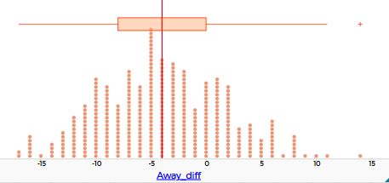
Notice that this variable works the same way that Home difference works. Positive values indicate a team won more games than they lost when playing away and negative values indicate that they lost more away games than they won.
Suppose we want to predict who is more likely to win in a match up. How can we use the values in this distribution to make a determination. Explore this by selecting two teams, finding their values for Away difference variable and then comparing them.
Team | Away difference
- Which team would you expect to win? Why?

So far, we’ve been deciding by comparing the numbers. That works—but it doesn’t tell us how much better one team is than another. Let’s make that more precise. Notice that the difference in these two values is 2 - (-11) = 13.
- What does 13 tell us about how the teams compare that we couldn’t see from just 2 > –11?

- Let’s test this model on the teams that competed in the sweet 16 matches in the March Madness Tournament. The teams in the sweet 16 and their corresponding Away Difference values are given below. Use them to identify who should have won in each match up.
School | Away difference | School | Away difference
Duke | 9 | Arizona | 8
St. John’s | 8 | Arkansas | 0
Michigan St. | 2 | Texas | -2
UConn | 7 | Purdue | 5
Iowa | -5 | Michigan | 11
Nebraska | 4 | Alabama | 4
Illinois | 6 | Tennessee | 0
Houston | 3 | Iowa St. | 0

School 1 | School 2 | Comparison | Who should win?
Duke | St. John’s
Michigan St. | UConn
Iowa | Nebraska
Illinois | Houston
Arizona | Arkansas
Texas | Purdue
Michigan | Alabama
Tennessee | Iowa St.

- Was your model able to predict a winner for every game? Use the bracket to identify the winner of each match and see if the model was correct?

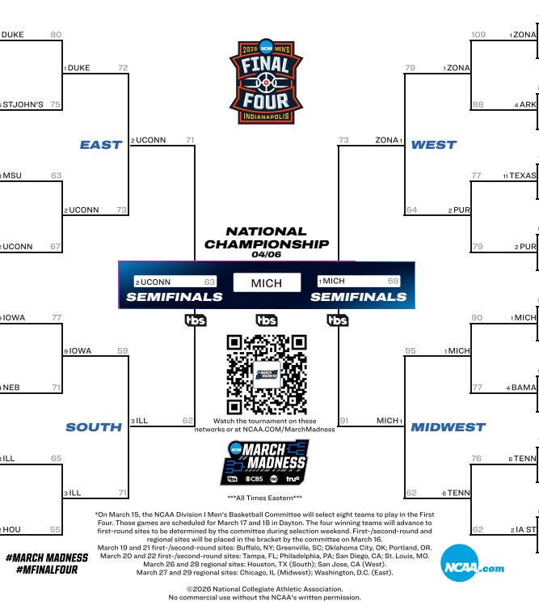

https://www.ncaa.com/march-madness-live/bracket

- How accurate was the model? That is, what percentage of games did it predict correctly?

- When did the model fail, and what information might be missing from our model?

- Would you recommend using this statistic in the future for predicting which team might win a game? Explain.

Activity 3: How can we improve our model?
Is there another statistic that could do a better job predicting outcomes? Can we combine more information with our current model to make better predictions?
- Use CODAP to explore different inputs and create a new variable that you think might improve the model.
You might consider:
- Combining home and away performance
- Using total wins and losses
- Creating a new statistic that includes multiple pieces of information
Once you create your new model:
- Use it to predict the same matchups from Activity 3
- Compare your predictions to the actual results
- Calculate the accuracy of your new model
Reflection
- Did your new model improve the accuracy?

- In what ways is your model better or worse than the original?

- What might your model still be missing?

