Activity 1: Getting to know a nutrition label
What’s in a label? Specifically, nutrition labels. Any food item you buy from the grocery store has a nutrition label on it that communicates information about the contents of the food. Below is an example label and explanation of each item.
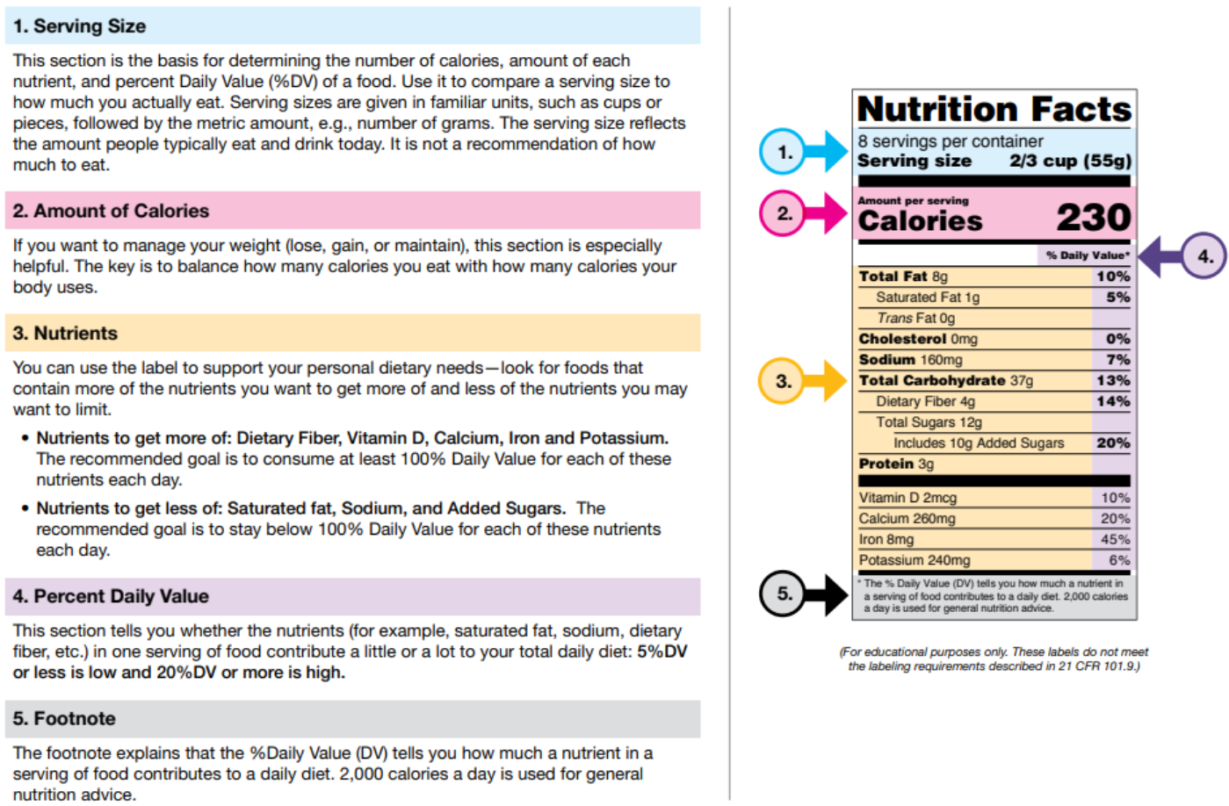
Source: https://www.fda.gov/food/nutrition-food-labeling-and-critical-foods/nutrition-facts-label-images-download

- How much of each food item should be consumed based on the nutrition label?
Below is the nutrition label from a bag of Taki’s.
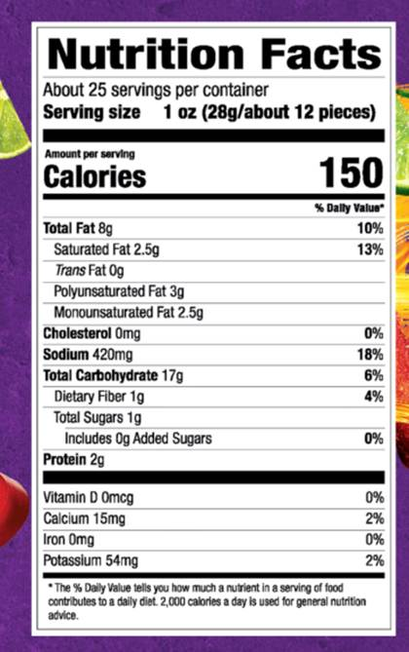
Source

Notice that it tells us the percent but not the actual amount. Use algebra to determine the following.
- How much Total Fat should be consumed in a day?

- How much sodium should be consumed in a day?

- How many carbohydrates should be consumed in a day?

Below are the actual amounts of each item that should be consumed in a day as stated by the FDA. Compare your values to these.
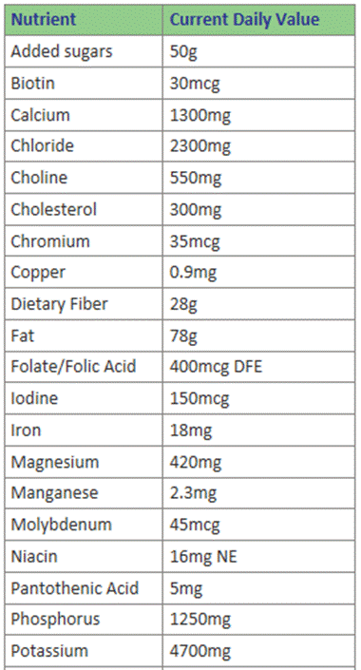 | 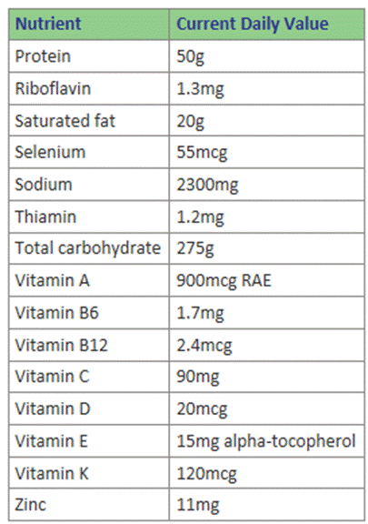
If you were making the nutritional label, calculate the values that would be displayed based on the table above.
- What percent of the current daily value of Fat is the 8 g?

- What percent of the current daily value total sodium is 420 mg?

- What percent of the current daily value carbohydrates is 17 g?

- Do the values you calculated from the label match the ones you just identified? If not, can you explain why?
The FDA has specific guidelines for rounding on nutritional labels and they are presented below.
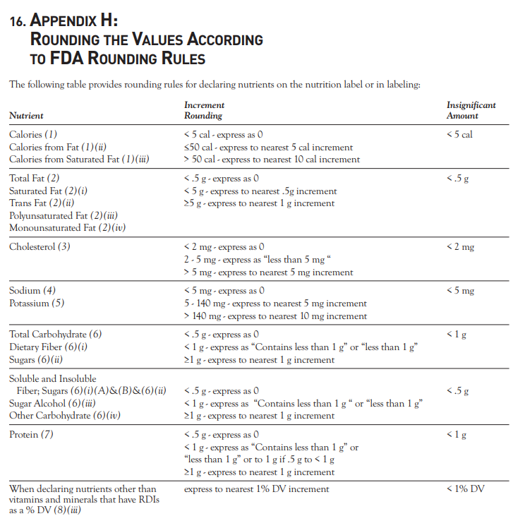
Source: https://www.fda.gov/files/food/published/Food-Labeling-Guide-%28PDF%29.pdf

- Consider the Takis label we are exploring. Based on the rounding rules provided by the FDA, use inequalities to indicate a range of values that the actual value might be for each of the nutritional items identified.
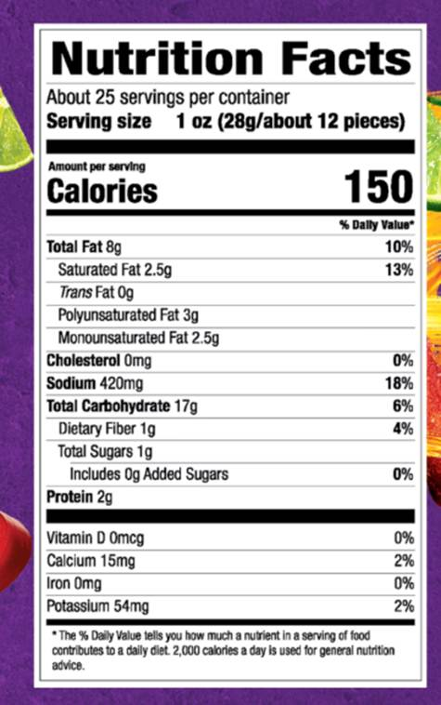

Nutritional Item | Value on label | Possible real value
Calories
Saturated fat
Trans Fat

- Do you agree with the rounding rules the FDA uses? What are some benefits to using these rules? What are some drawbacks?

Activity 2: Going out to eat
Open the following CODAP document which contains the food items offered at McDonalds along with the nutritional information about each food item.
McDonald’s Menu
- Create a graph of the calories of all food items at McDonald’s. What do you notice?

- Which food item has the most calories?

- Let’s create the nutrition label for this food item. We will only focus on a few of the nutrition items. Fill in the table below for the items indicated.

Nutritional item | % of daily value | Rounded % of daily value
Calories
Total fat
Cholesterol
Sodium

- How do calories compare for different food categories? Create a graph that shows the calories by food type by clicking on the y-axis and adding the food category as a variable. What do you notice about this graph?

Activity 3: Creating a meal
If we assume that a person eats 3 meals a day then one meal at McDonald’s should consist of ⅓ or 33% of the daily nutritional values consumed.
- How much would this be for each of the following categories?

Nutrition Item | Total Daily Amount | 33% of each value
Calories | 2000 calories
Total fat | 78 grams
Sodium | 2300 mg
Carbohydrates | 300 grams

- Can you create a meal using these values? Return to the graph in CODAP and identify the main entree or burger, side, and beverage so that at least 3 of the 4 nutritional values do not exceed the values you found for each nutritional item.

Food Item | Calories | Total fat | Sodium | Carbohydrates

- What percent of the daily values is your meal?

Nutrition Item | Total amount in meal | % of daily amount allowed
Calories
Total fat
Sodium
Carbohydrates

- Now create a meal that you think a typical person might order at McDonalds or a meal you might order and identify the same values.

Food Item | Calories | Total fat | Sodium | Carbohydrates

- What percent of the daily values is your meal?
Nutrition Item | Total amount in meal | % of daily amount allowed
Calories
Total fat
Sodium
Carbohydrates

- How does the meal that you created that meets the ⅓ nutritional daily requirements compare to the typical meal or meal you order at McDonalds?

Activity 4: Extension
- What is the nutritional value of your favorite meal?
- Use the following website to find the menu for your favorite restaurant. When you open the page, go to the most recent year that there is data for(2022) and download the file.
- Open the excel file. MenuStat

- Next we need to select only the observations that are for your restaurant. Click the drop down menu for column E which identifies the restaurant by name. Deselect the Select all check box and then go and find your restaurant and click the box next to it. Select OK and you will now see only your restaurant's observations. | 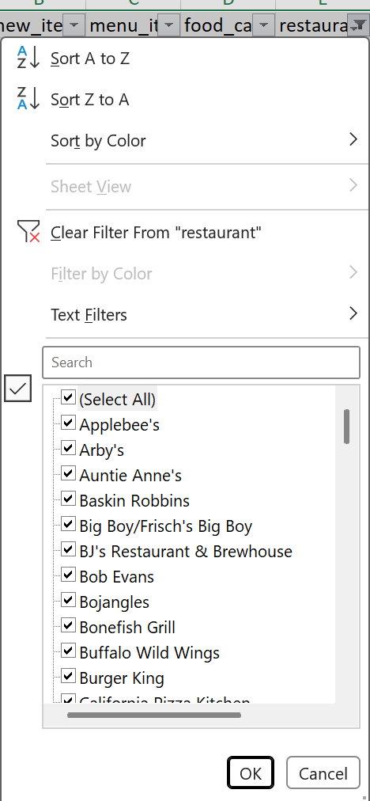
- We want to export this data. Copy all the information on the spreadsheet (CTRL+A and then CTRL+C). Go to file, new document. Paste the information (CTRL+V). Go to file and export, change file type, select CSV | 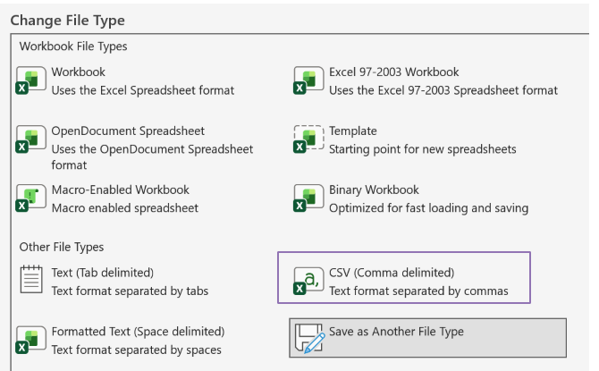
- Now open CODAP. Go to file, import, select the file you saved.

Explore your favorite food items by making graphs of the main nutritional items we have analyzed. In the data table you can select your favorite food items by clicking the row with the first one, then hold the control button and click additional rows.

- What do you notice about your favorite food items?

- Analyze your favorite meal. Select the food items and identify the values below for each of them.

Food item | Calories | Total fat | Sodium | Carbohydrates
Total

- Make a food label for your meal. Complete the nutrition label for your meal.
Nutritional item | % of Daily value
Calories
Total fat
Sodium
Carbohydrates

Option 1: Computer generated label  Now generate an actual nutrition label! Go to the following website and enter the values you found. Enter the values you identified above and leave all other entries blank. Once they are entered select generate nutrition label and it will generate a nutrition label below the table where you entered the values. Copy it below or print it out.  Nutrition label generator | Option 2: Student generated label  