Lesson Plan: Distance, Rate, and Time
Lesson Overview
Description | In this lesson, students explore the concept of rate through the real-world context of commercial air travel. Beginning with their own estimates of airplane speeds, students confront the variability in their thinking and develop a need for more precise methods. Using real flight data, they calculate rates, analyze distributions, and identify a typical speed for airplanes traveling between New York City and Los Angeles.  Students then extend their understanding by examining how time and speed are related when distance is held constant. Through tables, graphs, and dynamic modeling in CODAP, they discover that speed and time form an inverse relationship. By introducing extreme cases and visualizing a continuous function, students move from discrete data points to a generalized mathematical model.  The lesson emphasizes reasoning, representation, and explanation, helping students transition from viewing rate as a simple calculation to understanding it as a relationship that explains real-world variation.
Subject Area(s) | Mathematics
Grade Band(s) | 6-8

Learning Progression Alignment
Strand | Strand A — Dispositions and Responsibility
Substrand | Substrand A.1. — Nature of Data
Competency | Concept A.1.3 — Variability of data — Recognize that variability is a foundational component of data.  - 6-8.A.1.3a: Make sense of the variability of data through an iterative process of refinement by questioning.
Common Core | 6.RP.A.1  6.RP.A.2  6.RP.A.3  7.RP.A.1  7.RP.A.2

Tool(s)
Type | No-Code
Tool | CODAP  Spreadsheet
Programming Language | None
Other Tech Notes

Lesson Materials
Dataset | New York to LA Flight Data
Datasheet | Flights Data Sheet
Student Document(s) & File(s) | Student WS  New York to LA Flight Data CODAP
Teacher Document(s) & File(s) | Teacher WS (Key)

Lesson Plan
Lesson Plan
Lesson Focus | The lesson focuses on interpreting and calculating rate in a real-world context, analyzing variability in data, and using that data to discover and explain the inverse relationship between time and speed when distance is held constant.
Content Objective(s) | - Compute and interpret unit rates (miles per hour)  - Solve real-world problems involving rate (distance, time, speed)  - Convert and use units consistently (minutes ↔ hours)  - Analyze data distributions (center, spread, variation using dot plots)  - Describe relationships between variables (time and speed)  - Graph and interpret relationships (including non-linear patterns)  - Recognize and explain an inverse relationship (as time increases, speed decreases when distance is fixed)  - Use mathematical models
Prerequisite Knowledge & Skills | Students should be able to:  - Basic division with decimals  (e.g., dividing distance by time to find rate)  - Understanding of fractions and conversion  (especially converting minutes to hours, e.g., 4660\frac{46}{60}6046​)  - Concept of rate as “per”  (e.g., miles per hour, even if informal)  - Familiarity with units of measurement  (time in hours/minutes, distance in miles)  - Reading and interpreting tables  (extracting values and comparing them)  - Basic graph interpretation  (axes, coordinates, increasing/decreasing trends)  - Experience with dot plots (introductory)  (recognizing center and spread at a basic level)
Lesson Hook & Warm-up  15 mins | STUDENT FACING  Student WS Warm up
Lesson Hook & Warm-up  15 mins | TEACHER FACING  1. Launch — Estimation (5–8 min)  - Prompt students to estimate airplane speed in miles per hour.  - Record all estimates in a dot plot on the board.  Facilitate discussion:  - Press for observations about center, spread, and shape.  - Ask students to explain the variation in estimates.  Key idea to surface:  - Variation exists because students are guessing without consistent information.
Activity 1  35-40 mins | STUDENT FACING  Activity 1 on Student WS
Activity 1  35-40 mins | TEACHER FACING  1. Introduce a Real Flight (10–12 min)  - Display a real flight (NY → LA, distance = 2,475 miles, time ≈ 6h 26m).  Facilitate noticing:  - Ask what students observe about how time is presented.  - Guide them to identify hours and minutes.  Press for unit reasoning:  - Ask how to align time with miles per hour.  - Elicit the need to convert time to hours only.  Support conversion if needed.  Have students compute the rate.  2. Compare to Estimates (3–5 min)  - Ask students to compare this value to the center of their warm-up estimates.  Prompt:  - Is this value close to the center or far from it?  Key idea:  - This value is reasonable but not exact.  3. Consider Variation (5–7 min)  - Ask whether this is the speed for all planes.  Look for:  - Students recognizing it is not exact  4. Expand to Multiple Flights (8–10 min)  - Display a list of nonstop NY → LA flights.  Facilitate noticing:  - Flight times vary, but are close (≈ 6–6.5 hours).  Press reasoning:  - Ask what varying time implies about speed.  - Ask whether speeds will be very different or slightly different, and why.  Key idea:  - Similar times imply similar speeds.  5. CODAP Exploration (10–12 min)  - Have students compute speeds for assigned flights using the dataset.  Circulate and prompt:  - “What speeds are you getting?”  - “What range do you see?”  - “Are the values similar or very different?”  6. Analyze the Distribution (5–7 min)  - Lead discussion of the dot plot.  Focus on:  - Center (≈ 395 mph)  - Range (≈ 375–410 mph)  - Comparison to warm-up estimates  Key idea:  - Real data shows a tight cluster around a typical value. Why does this data have less variation than our class estimates? Students should recognize that this is “Better” data because it is a sample of real flights rather than guesses.  7. Synthesis (3–5 min)  - Ask students to describe plane speed based on data.  Goal statement:  - Planes travel within a range, with a typical speed around 400 mph.  Optional prompt:  - Why were the original estimates more spread out?  Key idea:  - Data reduces uncertainty and refines understanding.  Instructional Emphasis  - Keep focus on unit consistency  - Let students justify conversion decisions  - Emphasize:  Same distance + similar time → similar speed
Activity 2  35-40 mins | STUDENT FACING  Activity 2 on Student WS
Activity 2  35-40 mins | Teacher Facing  1. Reconnect to Activity 1 (3–5 min)  - Remind students that all flights traveled the same distance (2,475 miles).  - Prompt students to recall that speeds varied slightly.  Key question:  - “If the distance stays the same, what is different about the flights?”  Look for:  - Time varied  2. Make a Prediction (5–7 min)  - Pose the question:  “If two flights travel the same distance, but one takes more time, what happens to its speed?”  - Have students commit to an answer (write or quick share).  Look for:  - More time → lower speed  Press for reasoning:  - Students should reference dividing by a larger number  3. Table Exploration (8–10 min)  - Provide times from 6.0 to 6.5 hours.  - Have students compute speeds using:  rate=2475*time  Teacher move:  - Ensure students complete at least several rows  Key question:  - “Are the speeds decreasing at a constant rate?”  Look for:  - Not constant, but close  Key idea:  - Change is not linear  4. Predict the Graph (3–5 min)  - Ask:  “If the speeds are not changing at a constant rate, what does that suggest about the graph?”  Look for:  - Students should indicate that it is not a line but may have some trepidation about explaining it. Leave this open and continue.  5. Graph in CODAP (5–7 min)  - Students create a graph:  - x-axis: time (hours)  - y-axis: rate (mph)  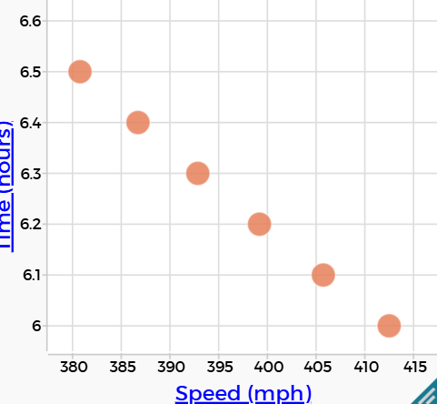  Discussion prompt:  - “Does the graph match your prediction?”  Look for:  - Appears nearly linear. Students may not like this as they predicted it shouldn’t be. Encourage them to keep exploring.  6. Introduce Extreme Values (8–10 min)  - Present:  - 50 mph → 49.5 hours  - 2,193 mph → 1.13 hours  Ask:  - “Where would these points appear on the graph?”  Look for:  - Slow → bottom right  - Fast → top left  Next question:  - “Will adding these points change the shape of the graph?”  Key idea:  - It cannot be linear so it must curve to include these points.  7. Update Graph (CODAP) (3–5 min)  - Students add extreme values and re-graph. There are two rows available for these observations. Students can enter them manually or a new CODAP document can be provided that includes them.  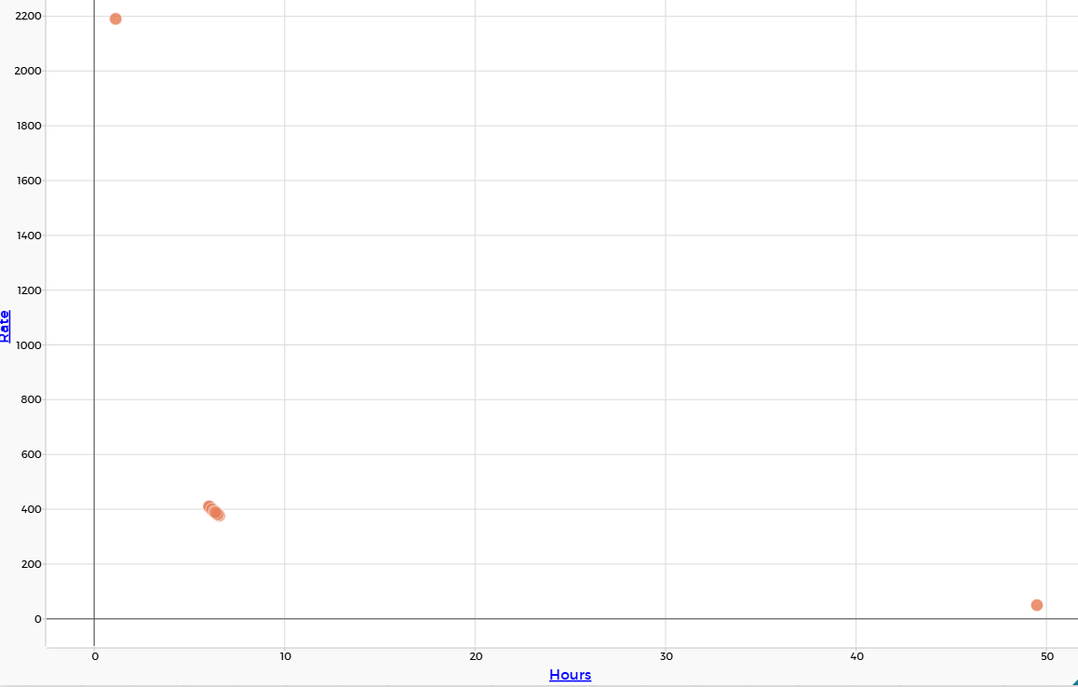  Prompt:  - “What do you notice now?”  Look for:  - Clearly curved pattern  8. Model with a Function (5–7 min)  - In CODAP, add plotted function:  2475 / Hours  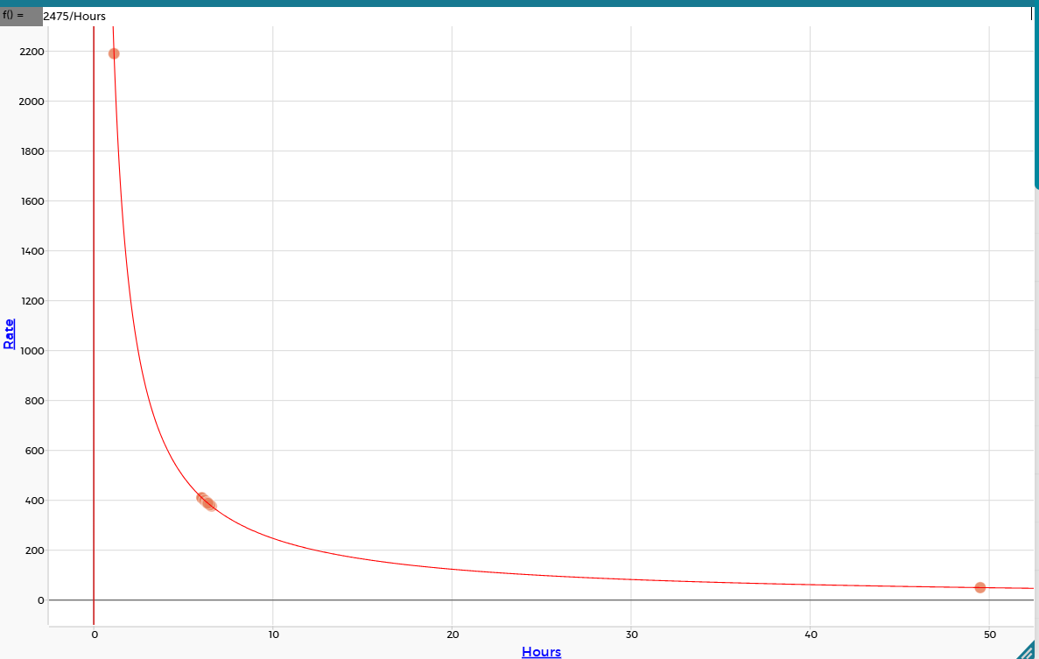  Ask:  - “Why does this curve go through all of our points?”  Look for:  - Same formula used to generate values  9. Interpret the Relationship (5–7 min)  - Prompt:  “What does this function tell us about how speed changes as time changes?”  Look for:  - As time increases, speed decreases  - Name the relationship: This is an inverse relationship  10. Asymptotic Reasoning (5–7 min)  Ask:  - “Will this graph ever touch the x-axis or y-axis?”  Look for:  - No intersection  Press reasoning:  - Time = 0 → undefined (division by zero)  - Speed approaches 0 but never reaches it  Key idea:  - Values approach but never reach the axes
Lesson Synthesis  5 mins | TEACHER FACING  Bring students back together and display the graph, table, and function from Activity 2.  Facilitate a discussion connecting the major ideas from the lesson.  Ask:  - “What relationship did we discover between time and speed when distance stays the same?”  - “How did the graph help us understand that relationship?”  - “Why were the speeds from Activity 1 clustered near 400 mph?”  Look for:  - As time increases, speed decreases.  - The relationship is inverse, not linear.  - Flights traveled similar distances in similar amounts of time, so their speeds were also similar.  - The graph, table, and equation all represented the same relationship in different ways.  - Real-world data has variation, but patterns still emerge.  Key ideas to reinforce:  - Rate is a relationship between two quantities.  - Real-world data varies, but data can still reveal predictable patterns.  - Mathematical models help explain and predict real situations.  - When distance is fixed, speed depends on time.  Conclude with:  “Today we used real flight data to move from estimates and guesses to mathematical reasoning. We used tables, graphs, equations, and data visualizations to explain why airplane speeds cluster around a typical value and how changing one quantity affects another.”
Closing Activity  5 mins | STUDENT FACING  Respond to the following prompt:  A flight travels 2,475 miles.  Explain what happens to the speed of the airplane if the travel time increases. Use words, numbers, or a graph in your explanation.
Closing Activity  5 mins | TEACHER FACING  Have students complete an individual written response.  Look for:  - Recognition that increasing time decreases speed.  - Use of the inverse relationship idea.  - References to the equation or graph.  - Explanations grounded in the flight context rather than only procedures.  Optional extension prompt:  - “Why doesn’t the graph ever touch either axis?”  This provides a final opportunity for students to articulate both the mathematical relationship and the real-world meaning behind it.
Student Follow Up & Practice | There is actually more to explore in the CODAP Data file. Ask students if there is a reason certain flights would travel slower or faster for the same route and explore the data to investigate this question. Some possible items they notice are that time of day has a relationship: 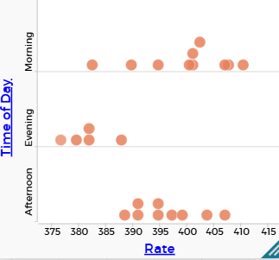  Evening flights tend to go slower.  Airline also makes a difference:  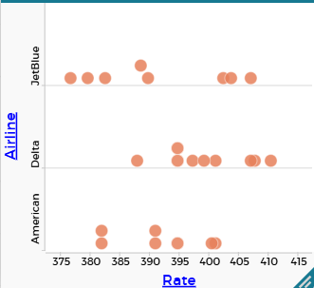  Delta tends to go faster.
References

