Lesson Plan: Classifying Quadrilaterals

Lesson Overview
Description | In this lesson, students develop an understanding of classification by creating and refining decision trees. They begin by generating and evaluating yes/no questions to efficiently identify objects, recognizing how effective questions narrow possibilities. Students then apply this thinking to geometry by grouping quadrilaterals based on their properties and developing questions to distinguish between them. Using a dataset in CODAP, they organize and test their questions to build a structured decision tree, repeatedly selecting variables that best divide the data. Students evaluate and revise their trees to ensure each shape is uniquely classified, and label each branch with the appropriate quadrilateral. The lesson concludes with reflection on the efficiency and accuracy of their trees and connections to real-world uses of classification in data analysis and decision-making systems.
Subject Area(s) | Mathematics
Grade Band(s) | 6-8

Learning Progression Alignment
Strand | Strand C — Analysis and Modeling Techniques
Substrand | Substrand C.5. — Models of Data  Substrand C.2. — Identifying Patterns and Relationships in Data
Concept | Concept C.5.2 — Creating models — Develop an understanding of patterns and relationships. Use data and technology to build and refine models. Advance these skills by constructing complex models that incorporate multiple variables, assess assumptions, and improve predictions.  - 6-8.C.5.2a: Identify relationships between variables and represent them using tables, graphs, or diagrams (e.g., decision trees, flowcharts).  - 6-8.C.5.2b: Use simple mathematical or computational models (e.g., statistical summaries, spreadsheet formulas) to describe patterns and relationships in data.  - 6-8.C.5.2c: Test and refine models by comparing predictions to actual data values.  Concept C.2.3 — Defining relationships — Organize, visualize, and analyze data to identify patterns, trends, and associations. Use statistical measures and graphs to interpret relationships and make predictions.  - 6-8.C.2.3a: Employ complex graphs (e.g., bar graphs, line graphs) and basic statistical concepts (e.g., mean, median, mode) to describe patterns and identify trends, similarities, and differences within data.  - 6-8.C.2.3b: Create scatterplots and add line of best fit.
Common Core | 7.EE.A.1: Apply properties of operations as strategies to add, subtract, factor, and expand linear expressions with rational coefficients

Tool(s)
Type | Code
Tool | CODAP
Programming Language
Other Tech Notes

Lesson Materials
Dataset | Student file:  Quadrilaterals CODAP  Spam Filter CODAP  Teacher file:  Quadrilaterals Teacher CODAP
Datasheet | Quadrilaterals Datasheet
Student Document(s) & File(s) | Student WS
Teacher Document(s) & File(s) | Teacher WS

Lesson Plan Template 1
Lesson Plan
Lesson Focus | In this lesson, students will develop and refine yes/no questions to identify objects and organize those questions into a structured decision tree. They will compare different questioning strategies to evaluate efficiency while grouping quadrilaterals based on shared geometric properties such as parallel sides, congruent sides, and angle measures. Using these properties, students will generate classification questions and explore a dataset in CODAP to connect variables to their questions. They will create graphs to determine which variables best divide the data and use this information to iteratively build a decision tree by selecting the most effective questions at each step. Students will test their decision tree to classify observations, revise and improve it to ensure each shape is uniquely identified, and label the final branches with the appropriate quadrilateral names. Throughout the process, they will explain and justify their reasoning using both data and geometric properties, and reflect on the efficiency and accuracy of their classification system.
Content Objective(s) | Classify two-dimensional figures based on their properties  - Identify and distinguish quadrilaterals using attributes such as parallel sides, congruent sides, and angle measures.  Understand and use hierarchical relationships among shapes  - Recognize how categories of quadrilaterals are related (e.g., squares as a type of rectangle and rhombus).  Use properties of shapes to make and justify decisions  - Apply geometric definitions and attributes to classify figures logically.  Develop and use logical reasoning  - Construct and follow a sequence of decisions (if/then reasoning) to reach a conclusion.  Organize and interpret data  - Use tables and graphs to explore how variables divide a dataset.  Analyze how variables affect classification  - Determine which attributes best separate groups within a dataset.  Create and evaluate mathematical models  - Build and refine decision trees as models for classification.  Communicate mathematical reasoning  - Explain and justify classification decisions using appropriate mathematical language.
Prerequisite Knowledge & Skills | Recognizing and describing quadrilaterals  - Students should be familiar with basic quadrilaterals (square, rectangle, parallelogram, trapezoid, etc.), even if they do not yet fully understand all relationships between them.  Understanding geometric properties  - Students should be able to identify:  - parallel sides  - congruent sides  - right angles and general angle measures  Using mathematical vocabulary  - Students should be comfortable with terms such as side, angle, parallel, congruent, and polygon.  Basic measurement skills  - Ability to read or interpret diagrams and, if needed, use tools to identify properties.  Interpreting tables of data  - Students should be able to read and extract information from a table.  Basic graph interpretation  - Some familiarity with simple graphs (e.g., bar graphs or dot plots) to see how data is grouped.  Logical thinking and reasoning  - Ability to follow and create simple if/then statements (e.g., “If a shape has four equal sides, then…”).
Lesson Details
Lesson Hook & Warm-up  10 mins | STUDENT FACING  Play a round of 20 questions or Guess in 10. Once completed, engage students in a discussion using the prompts provided in the teacher facing directions.
Lesson Hook & Warm-up  10 mins | TEACHER FACING  Reflection Questions  - What types of questions were most helpful in narrowing down the answer quickly?  - Which questions were less helpful? Why?  - How did your questions change as you got more information?  - Did you notice any patterns in the kinds of questions people asked?  - What made one strategy more efficient than another?  Connecting to Classification  - Were your questions helping you eliminate many options or just a few?  - What kinds of questions helped divide the possibilities into clear groups?  - If you could play again, what would you ask first? Why?  - How could you organize your questions so you don’t repeat or waste guesses?  Bridging to Decision Trees (Most Important)  - Could we organize these questions in a way that always leads us to the answer?  - What if we had a set of questions we always asked in the same order?  - How could we turn your questions into a system that someone else could follow?
Activity 1  15-20 minutes | STUDENT FACING  In this activity, you will begin exploring how decision trees work.  Use the worksheet to:  - Brainstorm questions that could help identify an animal  - List possible answers for each question  - Think about how your questions help narrow down the choices  Be prepared to share your questions and explain how they help identify the animal.

TEACHER FACING
Purpose:
Students are introduced to decision trees as a structured method for classification and begin developing questions that efficiently narrow possibilities.

Launch
Introduce the concept:
A decision tree is a systematic way of answering a question when there are multiple possible answers.
Present the list of animals and briefly connect to the prior warm-up:
Instead of guessing randomly, we can organize our questions in a way that guarantees we reach an answer.

Step 1: Brainstorming Questions
Have students work in pairs or small groups to generate questions and possible answers.
Encourage questions that:
- Can be answered clearly (preferably yes/no or a small set of options)
- Divide the animals into meaningful groups
Circulate and support with prompts:
- Does this question separate the animals clearly?
- How many animals does this question eliminate?

Step 2: Building the Decision Tree
Students use their questions to construct a decision tree.
Remind students:
- Each question should narrow the possibilities
- Each branch should lead closer to a single animal
- The final branches should identify exactly one animal
Avoid over-directing structure—allow for multiple valid trees.

Step 3: Share and Compare
Have students share their trees with another group.
Ask them to evaluate:
- Does the tree correctly identify all animals?
- How many questions are needed to reach a final answer?

Whole-Class Discussion
Select a few trees to share.
Focus the discussion on:
- Efficiency (fewer questions, better early splits)
- Structure (how questions are organized)

Key Idea to Highlight
The most effective decision trees ask questions that eliminate as many possibilities as possible early on.
Activity 2  25-30 minutes  15-20 minutes if modified as noted. | STUDENT FACING  Activity 2: Creating Questions for a Decision Tree (Quadrilaterals)  In this activity, you will explore how to classify quadrilaterals.  Use the shapes and your worksheet to:  Group quadrilaterals based on shared properties  Create questions that could be used to identify each group  List possible answers for each question  Be prepared to:  Explain how you grouped the shapes  Share your questions and how they help classify quadrilaterals  Discuss which questions are most useful for narrowing down the possibilities
TEACHER FACING
Purpose:
Students analyze properties of quadrilaterals and generate classification questions, preparing them to build a decision tree in the next activity.

Launch

Connect to Activity 1:
In Activity 1, you used questions to identify animals.
Now we will use that same idea to classify shapes.
Frame the task:
Before we build a decision tree, we need to decide what questions to ask. Good questions are based on properties that help us tell shapes apart.

Step 1: Grouping Quadrilaterals
Distribute the 35 shapes. Note, if time is a factor or students do not need as much practice, the number of shapes can be reduced to 10 which should save about 10 minutes.
Have students work in pairs or small groups to:
- Group shapes based on shared properties
Circulate and prompt:
- What do these shapes have in common?
- What makes this group different from others?

Step 2: Generating Questions
Students generate questions that could be used to classify the shapes.
Remind students:
- Questions should be clear and based on measurable properties
- Answers should be limited (yes/no or a small set of options)
Provide examples if needed:
- Does the shape have two pairs of parallel sides?
- Are all sides congruent?
Support with prompts:
- Does this question separate the shapes clearly?
- How many shapes does this question eliminate?
- Could this question come earlier or later?

Step 3: Share and Refine
Have groups share their groupings and questions with another group.
Ask students to consider:
- Do these questions work for all shapes?
- Are any questions unclear or unnecessary?
- Which questions seem most useful?

Whole-Class Discussion
Bring the class together and highlight strong examples of questions.
Focus on:
- clarity of questions
- usefulness for classification
- how well questions narrow possibilities

Key Idea to Highlight
Good decision trees depend on strong questions—questions that clearly separate shapes based on their properties.
Activity 3  35-45 minutes | STUDENT FACING  Activity 3: Building a Decision Tree Using Data (CODAP)  Follow the instructions on your worksheet to:  Explore the quadrilateral dataset in CODAP  Compare the variables to the questions you created  Use the data to build a decision tree that classifies all shapes  Be prepared to explain:  How you chose each question  How you knew when a branch was complete
Activity 3  35-45 minutes | TEACHER FACING  Purpose:  Students use data to systematically construct a decision tree, applying their earlier questions and refining them based on how well variables divide the data.  Launch  Connect to the previous activity:  In Activity 2, you developed questions to classify quadrilaterals. Now you will use actual data to test those questions and organize them into a decision tree.  Emphasize the shift:  Instead of guessing which question to ask next, we can use data to help us decide.  Key Instructional Focus  Students will follow the worksheet, but your role is to highlight the underlying ideas:  1. Choosing the First Question  - Look for students identifying which variable “splits” the data most  - Press with:  - Why is this a good first question?  - How many groups does it create?  2. Recursive Thinking (Most Important)  Students often struggle with restarting the process.  Reinforce:  Once you isolate a group, you are starting the process over with a smaller dataset.  Prompt:  - What data are you working with now?  - Does the same “best” question still apply?  3. Recognizing When a Branch is Complete  Students may keep searching for another split.  Press:  - Can any variable further separate these shapes?  - If not, what does that tell you?  4. Connecting to Prior Work  Encourage students to compare:  - Their original questions  - The CODAP variables  Ask:  - Did the data confirm your thinking or change it?  Common Challenges to Watch For  - Students choosing variables randomly instead of based on how well they divide data  - Difficulty restarting the process after isolating a subset  - Not recognizing when multiple shapes still remain (incomplete branch)  - Over-focusing on CODAP mechanics rather than classification logic  Key Idea to Highlight  Building a decision tree is a repeated process:  choose the question that best divides the data, isolate a group, and repeat until each group contains only one type of shape.
Activity 4  20-25 minutes | STUDENT FACING  Activity 4: Testing and Refining Your Decision Tree  In this activity, you will test and improve your decision tree.  Use the shapes you grouped earlier to:  Test how well your decision tree works  Determine whether each shape is classified correctly  Revise your tree if needed  Be prepared to:  Explain how you tested your tree  Describe any changes you made  Compare your tree to others and discuss which is more effective
Activity 4  20-25 minutes | TEACHER FACING  Purpose:  Students evaluate and refine their decision trees to ensure accurate and unique classification, and compare different trees to consider both correctness and efficiency.  Launch  Frame the activity:  You’ve built a decision tree. Now we need to test whether it actually works.  Emphasize:  A strong decision tree should correctly classify every shape and lead to one clear answer.  During Work Time students will follow the worksheet to:  - Test one shape from each group  - Evaluate whether the tree works  - Revise as needed  Circulate and press thinking:  - How do you know this shape belongs here?  - Could this shape end up somewhere else in your tree?  - What question might help separate these shapes?  - Would asking this question earlier improve your tree?  Comparing Trees  Have students share their trees with another group and walk through one or two shapes using each tree.  As students compare, guide them to notice both similarities and differences.  Ask:  - Which trees begin in a similar way? Why might that be?  - Where do the trees start to look different?  - Do both trees still correctly classify the shapes?  - Which tree reaches a correct classification more quickly?  Make this idea explicit:  If we are using the data well, we should expect to see some similar decisions—especially at the top of the tree—because certain questions divide the data better than others.  Also emphasize:  Even if trees look different, they can still be correct. What matters is whether they correctly classify each shape and how efficiently they do so.  Whole-Class Discussion  Select 2–3 different trees to display.  Guide the discussion:  - What is similar about these trees?  - What is different about the order of questions?  - Why do many trees start with the same question?  - Are there multiple correct trees?  - Which tree is more efficient? Why?  Key Idea to Highlight  There can be multiple correct decision trees, but some are more efficient because they ask better questions earlier.  Common Things to Watch For  - Students assuming there is only one “correct” tree  - Students focusing only on correctness, not efficiency  - Missing the importance of strong early questions  - Trees that work but include unnecessary steps
Closing Activity  5-10 mins | STUDENT FACING  None
Closing Activity  5-10 mins | TEACHER FACING  Wrap up the activity be explaining the following to students:  “Let’s take a step back and think about what we just did.  You built decision trees that can take a shape and, by asking the right questions, lead to one clear answer. That’s pretty powerful.  But I want to change one thing.  What if I don’t show you the whole shape?  What if I only tell you a few properties—like:  - it has two pairs of parallel sides  - and its adjacent sides are equal  Now—based on just that information—what could the shape be?”  (Pause—students will likely say rhombus, square, maybe others)  “Right. There’s more than one possibility.  So now we have a situation where the tree doesn’t give us one definite answer—not because the tree is wrong, but because we don’t have enough information yet.  In real-world situations, this happens all the time.  So instead of giving one answer, we ask:  ‘What is the most likely answer?’  For example, if most of the shapes that match this information are rhombuses, and only a few are squares, we might say:  - it’s most likely a rhombus  - but it could still be a square  That’s where probability comes in.  A decision tree doesn’t always give a certain answer—it can also help us make the best possible prediction based on the information we have.  That’s how decision trees are used in things like medical decisions, spam filters, and AI systems—they use the information available to make the most likely decision.”
Student Follow Up & Practice | A dataset describing various emails is provided for students to use in creating a classification tree to determine whether an email is spam. In this case, we know if the message was spam or not and can use this to develop the tree. This is an extension of the previous exercise where we are developing a model based on a known set of outcomes, emails that have been identified as spam or not spam. Once the model (the tree) has been developed students will then test it on a new set of data to determine its effectiveness. This is a critical data science skill of developing a model using known data and testing it on data that was not used in developing the model before employing it on new observations.  For each variable, we can graph if it was spam along with how many messages had that characteristic. Here are all the variables graphed:  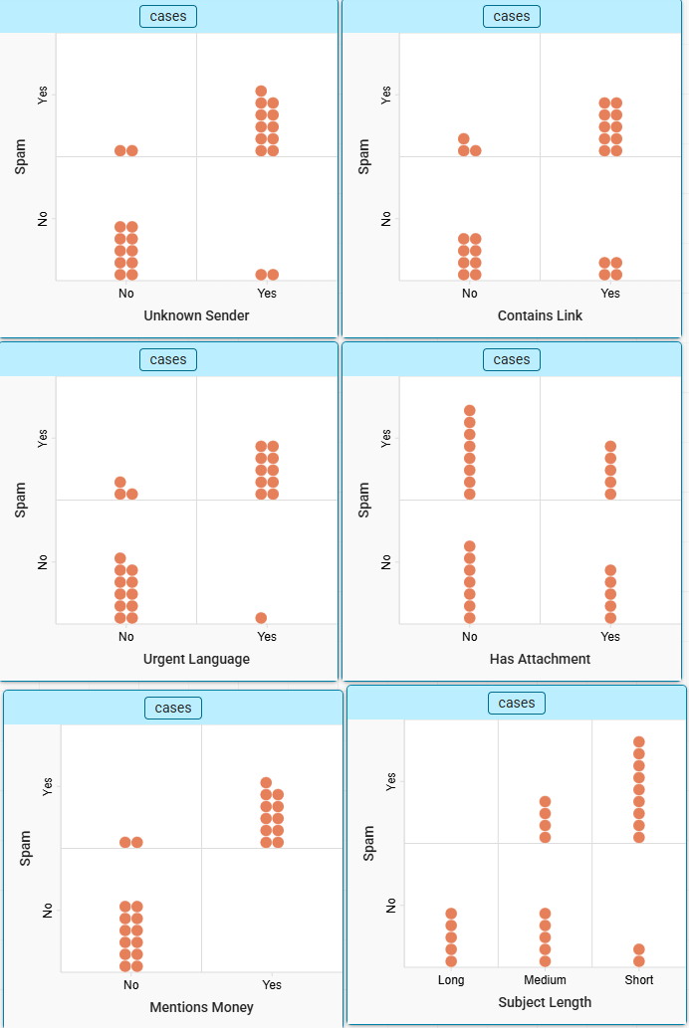  Ask students, how can we use these graphs to help us identify the best variable to use to classify a message as spam?  To determine the best variable we can ask which variable clearly characterizes all messages as spam or not spam, if any. The mentioned money variable shows that any message that mentioned money was spam. This should be our first branch. We can now focus on the remaining messages. We can highlight these messages that are spam and set them aside since they are classified.  Below are the remaining messages:  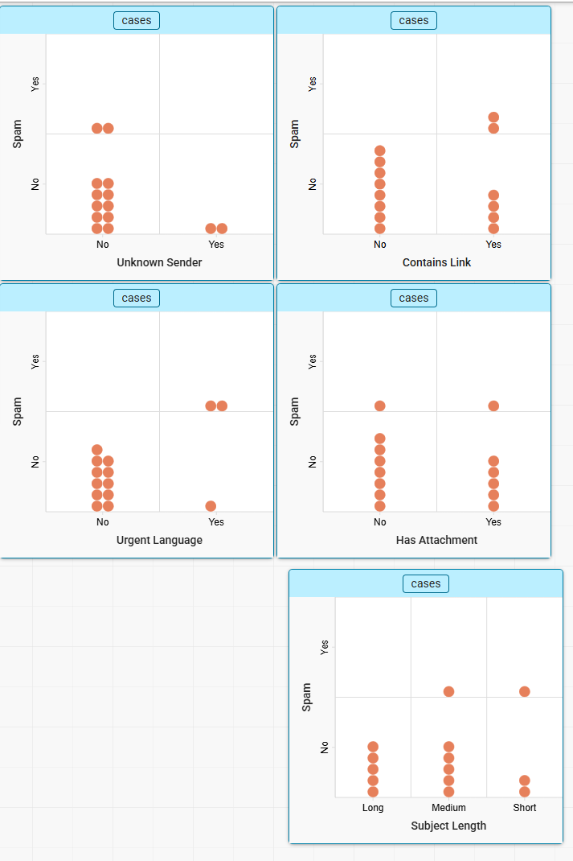  Next we could use “urgent language” or “contains link”. Both of these show that if there is no urgent language it was not spam or if there was no link it was not spam.  If we use urgent language and remove all messages that had no urgent language and were not spam we have the following:  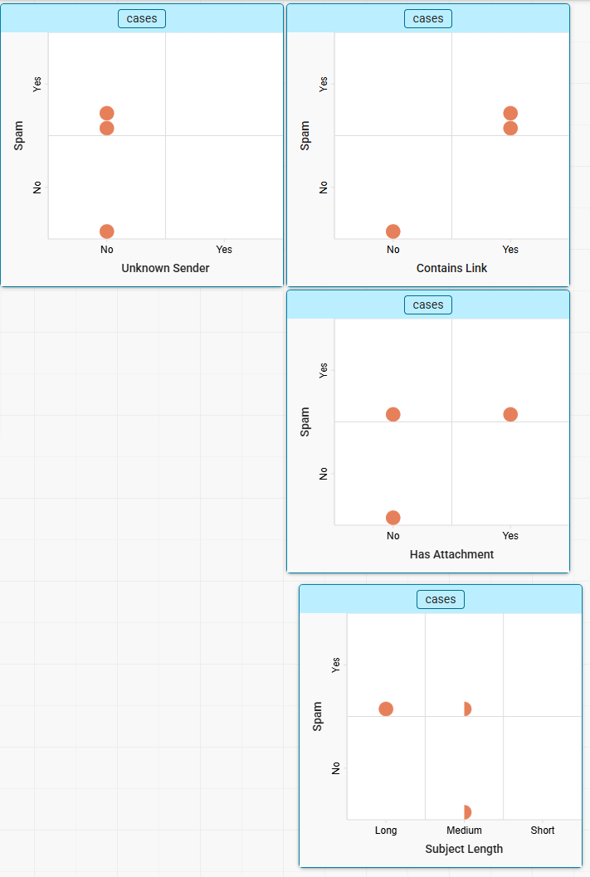  Now if we use “contains link” we can see that if it is yes, it is spam and if not, it is not spam. This now classifies all messages.  Since all messages have been classified we have a decision tree that can be used as our model. Students will test their decision tree with the new observations and determine which ones the model correctly identified.  Most likely, the model will have made at least 1 mistake and students should consider how they could revise or fine tune their model. This could be choosing a different question in the decision tree to use or perhaps adding another question. Data scientists must balance between keeping models simple while also maintaining their accuracy. An overly complex model may generate more correct answers but there is a cost in time and compute power that may be prohibitive. For example, a model that uses 1000 variables may be very accurate, but the time it takes to make a single prediction may be very long or it may be very challenging to have 1000 values for an observation.
References

