Activity 1: Using a decision tree
A decision tree is a systematic way of answering a question when there are multiple possible answers by asking a series of questions that narrow down the possibilities.
Suppose you are trying to identify an animal from the following list:
Shark, Goldfish, Owl, Eagle, Dog, Cat, Bear, Moose
We can use a decision tree to help us identify the animal.
What questions could help us identify the animal by narrowing down the possibilities?
Examples:
- How many legs does it have? → Possible answers: 0, 2, 4
- Can it fly? → Possible answers: Yes, No

Think about:
- Which questions divide the animals into clear groups?
- Which questions eliminate the most animals?

- Brainstorm some possible questions and their answers below:

Question
Possible Answers
Question
Possible Answers
Question
Possible Answers
Question
Possible Answers
Question
Possible Answers

Look at the questions you wrote and respond to the following prompts:

Which question do you think would be the best to ask first? Why?

Which question would be the least helpful? Why?

Now that you have your questions, construct your tree below.

Activity 2: Creating a decision tree for quadrilaterals
You will be given a set of 35 quadrilaterals. Organize the 35 quadrilaterals into groups that share similar properties. When you are done, write down a question that could be used to identify a quadrilateral that belongs in each of the groups you made. For each question, also right out the possible answers, these will help us with making branches.

Example questions:
If we were looking at polygons, we might ask how many sides a polygon has? Possible answers could be 3 for a triangle, 4 for a quadrilateral, 5 for a pentagon and so on.

If we had triangles and were trying to identify what type, we might ask are all the angles equal? The possible answers are yes or no.

- Write down your questions and answers in the table below:

Question
Possible Answers
Question
Possible Answers
Question
Possible Answers
Question
Possible Answers
Question
Possible Answers
Question
Possible Answers
Question
Possible Answers
Question
Possible Answers

Activity 3: Using CODAP to build a decision tree
An analysis of the same quadrilaterals you have been given is provided in the CODAP file below. Open it and explore the column headings (variables).
- Do they match the questions you identified? Do the possible answers match your possible answers? Are there any that you did not consider? If yes, add them to your table above.
Quadrilaterals
We can now use the data in the CODAP file to help us make a decision tree to identify the type of quadrilateral.
In the previous activity, you thought about which questions might be useful. Now, technology will help us determine which questions are the most effective and the best order to ask them. To determine what question should be asked first, we want to look at which variable divides the data the most. A variable divides the data the most when it creates the most number of groups.
- Create a graph and add a variable to the x-axis. Repeat this with the other variables.
- Which variable divides the data into the most groups?
The Parallel Pairs variable divides the data the most, so we should use it to make our first decision. How many possible answers are there to the question, “How many pairs of parallel sides does a quadrilateral have?”
- Use these answers to fill in the beginning of the decision tree below.
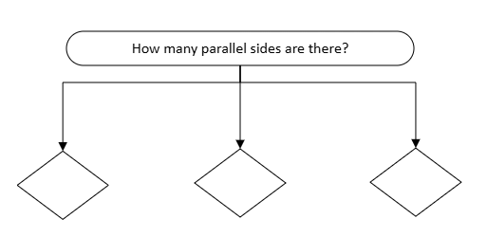

To make the next decision, we want to explore what happens after we answer this question. One option is that a shape has 0 parallel pairs of sides. Highlight these observations by selecting and holding a box around them on the graph using your cursor. In the data table, you will see these observations highlighted in blue. Click the eye icon and select “set aside unselected cases.”
Our dataset now only contains shapes with 0 parallel pairs of sides.
We will now repeat the process.Go to the x-axis, change each variable in the data table and determine which one divides this smaller dataset the most.
- Which variable divides the 0 parallel pairs of sides shapes the most?

- What are the possible answers to the question, “Are the adjacent sides equal?” Add this new decision to the decision tree.

Add this new decision to the decision tree:

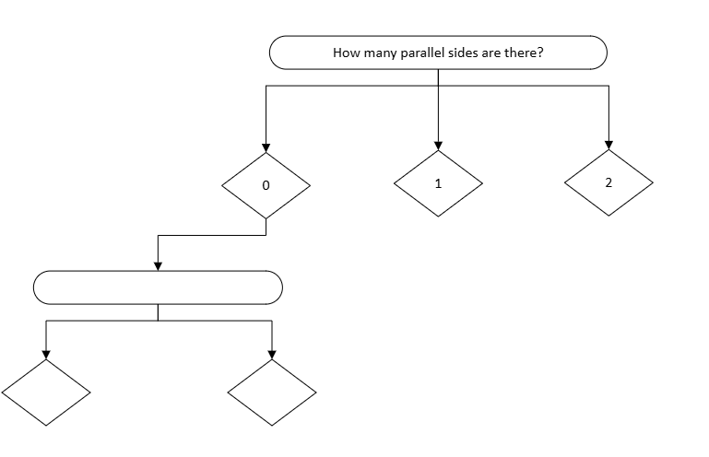

We will now repeat the process again. Highlight the observations that were “No” for the AdjacentSidesEqual variable. Click the eye icon and select “set aside unselected cases.” Go through each variable and determine which one divides these observations the most.
You will see that none of the variables divides these observations. This means that we have reached the end of this branch of the tree. We must now start over and repeat this process.
To continue, click the eye icon and select “Show All Cases.”This will bring back the original dataset. We have completed that branch of the tree and will next examine the observations with 1 set of parallel sides. Examine the observations with 1 set of parallel sides and then continue until you have completed the entire tree.
Repeat the process by:
- Dividing the data using the number of parallel pairs
- Selecting a group of observations
- Determining which variable best divides that group
Continue this process until the entire decision tree is complete.

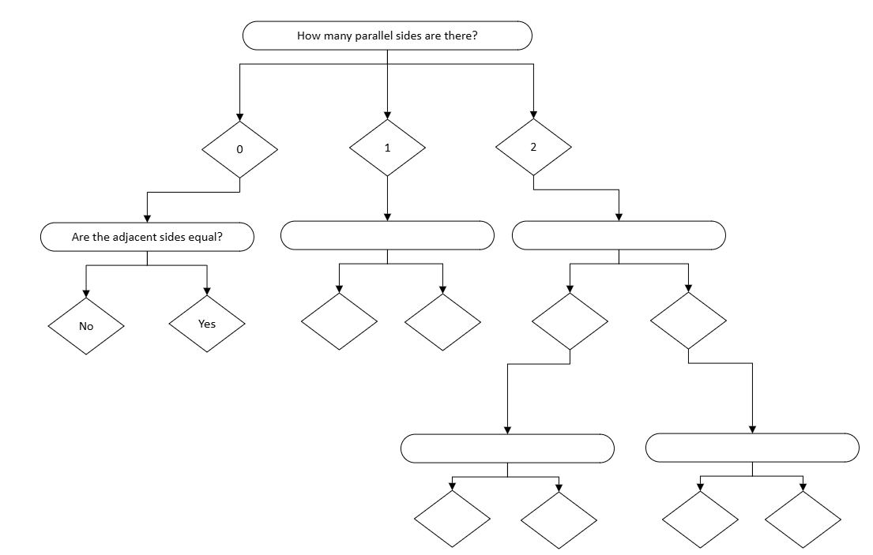

Activity 4: Testing and improving your decision tree
To see how well your decision tree works, you will now test it using the quadrilaterals you grouped earlier.
From each group you created, choose one quadrilateral. For each selected shape, begin at the top of your decision tree and follow the questions step-by-step until you reach the end of a branch. Determine where the shape ends up and consider whether that result makes sense.
As you test your shapes, think about the effectiveness of your tree. Does each shape lead to the correct classification? Does it clearly belong in only one branch, or could it fit in more than one place?
If you find that a shape is classified incorrectly or could belong in multiple branches, you will need to revise your tree. You may choose to add a new question, change the order of your questions, or improve a question so that it better separates the shapes.
Once your decision tree correctly identifies each shape, label the final branches using the appropriate quadrilateral names: square, rectangle, parallelogram, trapezoid, isosceles trapezoid, rhombus, kite, or irregular.
A decision tree is only effective if it leads to one clear classification for each shape.

Student Practice: Classifying Spam Emails Using a Decision Tree

You have used decision trees to classify quadrilaterals. You will now apply the same idea to a real-world situation: identifying spam emails. Open the link below to examine the data.
Email Data

Notice that there are 6 variables that describe a message and 1 variable that classifies it as Spam. These are messages that have already been classified so we can use this to help us determine the decisions on a tree for classifying future messages as spam.
Our first question is, which variable can help us identify a message as spam the best. Make a graph for each variable with the variable on the x axis. Next, add the Spam variable to the y axis. How can this representation help us determine which variable to choose to make our first decision?

Once a variable is identified, we can highlight the messages that were classified in the graph and then go to the data table and set those observations aside. We will repeat this process with the remaining variables and messages until we can reach a decision for all the variables.

What is the next variable you choose (Note there may be more than one variable that you can use, select the one you think is best) and explain how it classifies the messages (Ex:If a message mentions money then classify it as spam). Continue until you have correctly classified all messages and note your decisions below. You may be able to stop after 3 or 4 decisions.

Decision 2:

Decision 3:

Decision 4:

Decision 5:

Draw your decision tree below:

Once you have your decision tree we need to test it on new messages to see how well it works. Below are 10 new messages. How would your decision tree classify them?

Unknown Sender | Contains Link | Urgent Language | Has attachment | Mentions money | Subject Length | Spam | Decision tree result
Yes | Yes | No | Yes | No | Medium | Yes
No | Yes | Yes | No | No | Short | Yes
Yes | No | No | Yes | Yes | Long | Yes
No | No | Yes | No | No | Medium | No
No | Yes | No | Yes | No | Medium | No

How well did your decision tree do in classifying the new emails?

If it did not correctly classify all the emails, what changes might you make and why?

