Read the Data, Draw the Tree
Using PanTHERIA mammal data to build cladograms
Name: | Date: | Period:

Section 1: Background & Prediction
PanTHERIA and the challenge of classification
Before scientists had DNA sequencing or comprehensive fossil records, biologists had to classify organisms based entirely on what they could observe: body shape, diet, habitat, behaviour, and reproduction. This method produced many correct groupings. But it also produced spectacular errors, because sometimes unrelated organisms evolve to look or behave similarly in response to similar environments: a process called convergent evolution.
Today you will work with data from PanTHERIA, a published scientific database containing biological measurements for every known mammal species. You will use a sample of 15 species to try to reconstruct the mammalian family tree using only trait data, then find out where you got it right and where the traits misled you.
Q1 Make a prediction before you see the data.
Look at the 15 species listed in the table below. Based only on your general knowledge of these animals, not the data, which two do you predict are most closely related to each other? Explain your reasoning in one sentence.
Species in this dataset (common names)
Horse, African elephant, Bottlenose dolphin, Blue whale, Lion
Brown bear, Human, Rhesus macaque, Indian flying fox, Platypus
Red kangaroo, Common shrew, North American beaver, West Indian manatee, Nine-banded armadillo

My prediction (most closely related pair):
Reasoning:

90 Second Sort
- You and a partner have been given 15 small cards. Arrange the cards into groups according to how you think they may be related. You have 90 seconds to do this.

- You will then glue down your choices and put them aside.

- We will revisit your cards at the end of this lesson.

Section 2 Key Vocabulary
Term | Definition
Trait | A measurable biological characteristic of an organism that can vary between species
Similarity matrix | A table showing how similar every pair of species is based on chosen traits
Cladogram | A branching diagram showing hypothesised evolutionary relationships based on shared traits
Convergent evolution | When unrelated species independently evolve similar traits due to similar environmental pressures
Homology | Traits shared because of common ancestry, even if they look different in different species
Phylogeny | The actual evolutionary history and relationships of a group, established by molecular and fossil evidence

Q2. In your own words: what is the difference between a trait being similar because of homology versus convergence? Give a non-mammal example of each.

Section 3 Explore the Data in CODAP
Explore the dataset by creating graphs of different traits before you do the formal analysis.
Step | What to do | Done
1 | Open the CODAP file: https://codap.concord.org/beta#shared=https%3A%2F%2Fcfm-shared.concord.org%2Fe6fNR6mHkfO7VJDNg7TM%2Ffile.json | ☐
2 | Create a graph with common_name on the x-axis and body mass g on the y-axis. Observe the enormous range. | ☐
3 | Create a graph with diet_type on the x-axis and common_name on the y-axis. | ☐
4 | Create a graph with habitat on the x-axis and common_name on the y-axis. | ☐
5 | Create a graph with litter_size on the x-axis and common_name on the y-axis. | ☐

Q3. After exploring the graphs, identify one pair of species that share diet and habitat but that you suspect might NOT be closely related. Explain why you suspect this.
Pair I suspect are convergent:

Q4. The blue whale has a body mass of 100,000,000 g and the common shrew has a body mass of 8 g. Does body mass seem like a useful trait for figuring out evolutionary relationships? Why or why not?

Section 4 Choose Your Traits and Build a Similarity Matrix
Scientists who build cladograms have to decide which characteristics to use as evidence. Not all traits are equally useful, some reflect shared ancestry, others reflect shared environment. In this section you will choose 4 traits from a teacher-approved shortlist, justify your choices, and then use them to calculate how similar each pair of species is.
Step 4a Choose 4 traits from the shortlist below.
Each trait is described with a note about what it tends to reflect. Read the notes carefully before choosing.
Trait | What it measures | Likely to reflect... | Use?
Diet type | Whether the animal is herbivore, carnivore, omnivore, or insectivore | Environment -- diet can evolve rapidly and convergently | Circle if chosen
habitat | Primary habitat: grassland, marine, forest, freshwater, savanna, terrestrial | Environment -- closely tied to ecological niche | Circle if chosen
Activity cycle | Whether the animal is mainly diurnal or nocturnal | Mix -- partly ancestral, partly ecological | Circle if chosen
Litter size | Typical number of offspring per birth | Ancestry -- reproductive strategy is relatively conserved within lineages | Circle if chosen
Gestation days | Length of pregnancy in days | Ancestry -- gestation length is closely tied to reproductive anatomy, which is conserved | Circle if chosen
Max longevity years | Maximum recorded lifespan | Ancestry -- longevity correlates with body plan and metabolic rate | Circle if chosen
Typical social group size | Typical number of individuals in a group | Mix -- partly ancestral, partly ecological pressure | Circle if chosen
Body mass g | Adult body mass in grams | Environment -- body size varies widely even within orders and evolves convergently | Circle if chosen

My 4 chosen traits:
Trait number | Name of trait | Why I chose it -- what does this trait reflect that the others don't?
1
2
3
4

Q4a. Which trait from the shortlist did you choose NOT to include, and why? What is the risk of using that trait for classification?

Step 4b. Score each species on your 4 chosen traits.
Before you can compare species, you need to know exactly what value each one has for each of your chosen traits. Use your CODAP table to fill in the reference card below. This will make filling in the similarity matrix much faster.
Species | Trait 1: | Trait 2: | Trait 3: | Trait 4:
Horse
African elephant
Bottlenose dolphin
Blue whale
Lion
Brown bear
Human
Rhesus macaque
Indian flying fox
Platypus
Red kangaroo
Common shrew
North American beaver
West Indian manatee
Nine-banded armadillo

Step 4c. Calculate similarity scores.
For each pair of species, count how many of your 4 traits they share the same value on. Write that score in the matrix. 4 = identical on all 4 traits. 0 = share none.
How to score
For numerical traits (litter size, gestation days, max longevity years, body mass g): round to a category bracket rather than exact value. Your teacher will tell you the brackets to use, or you can sort the column in CODAP and divide the range into low / medium / high / very high.
For categorical traits (diet type, habitat, activity cycle): exact match = 1 shared trait, different value = 0 shared trait.
The matrix is symmetric -- if Horse vs. Lion scores 1, then Lion vs. Horse scores 1. You only need to fill in the upper triangle (above the diagonal) or lower triangle, then mirror it.

 | Horse | Elephant | Dolphin | Bl.whale | Lion | Bear | Human | Macaque | Fl.fox | Platypus | Kangaroo | Shrew | Beaver | Manatee | Armadillo
Horse | x
Elephant |  | x
Dolphin |  |  | x
Bl.whale |  |  |  | x
Lion |  |  |  |  | x
Bear |  |  |  |  |  | x
Human |  |  |  |  |  |  | x
Macaque |  |  |  |  |  |  |  | x
Fl.fox |  |  |  |  |  |  |  |  | x
Platypus |  |  |  |  |  |  |  |  |  | x
Kangaroo |  |  |  |  |  |  |  |  |  |  | x
Shrew |  |  |  |  |  |  |  |  |  |  |  | x
Beaver |  |  |  |  |  |  |  |  |  |  |  |  | x
Manatee |  |  |  |  |  |  |  |  |  |  |  |  |  | x
Armadillo |  |  |  |  |  |  |  |  |  |  |  |  |  |  | x

Section 5 -- A Cladogram Example
The cladogram below was built using 5 species and 4 traits: omnivore diet, diurnal activity cycle, forest habitat, and gestation under 200 days. Study the branching order and trait labels before building your own.
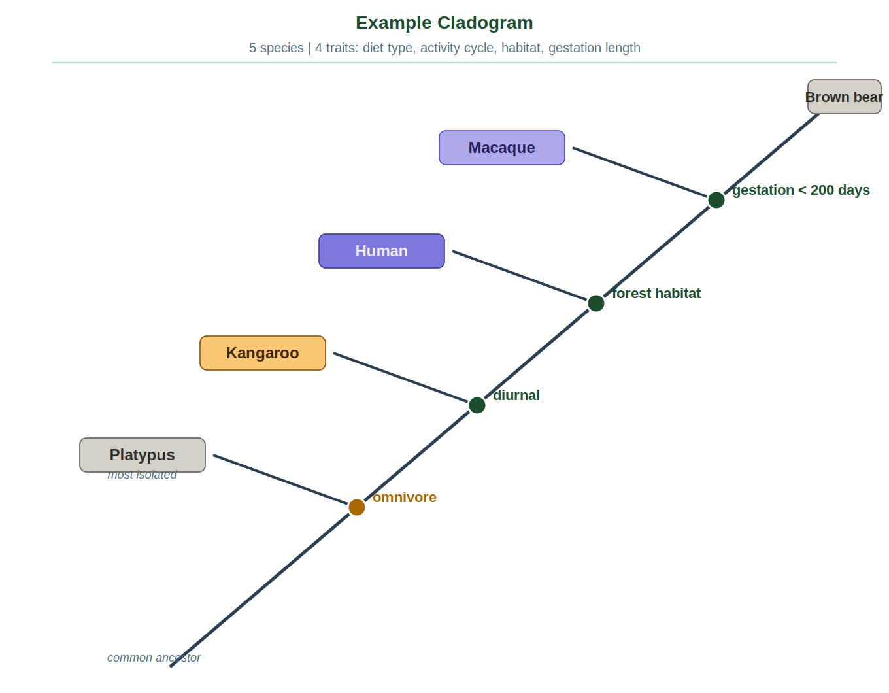

How to read this cladogram
Backbone runs diagonally from bottom-left to top-right. Brown bear sits at the very tip. All other species branch off to the left.
Node 1 — omnivore (amber) All species except Platypus are omnivores. Platypus is the only carnivore — it branches off here as the most isolated species.
Node 2 — diurnal Kangaroo is not diurnal, so it branches off here.
Node 3 — forest habitat Human does not live in a forest habitat, so it branches off here.
Node 4 — gestation < 200 days Macaque has a gestation under 200 days (166 days). Brown bear does not (225 days), so it continues to the tip of the backbone.

Common ancestry
Q1. According to this cladogram, which species share the most recent common ancestor — Macaque and Human, or Kangaroo and Human? How does the cladogram show this?

Q2. Where on the cladogram would you place the common ancestor of all five species? What does that position tell you?

Q3. Macaque and Brown bear share a common ancestor that is more recent than the one they share with Platypus. What evidence in the cladogram supports that statement?

Evolutionary relationships
Q4. Based on this cladogram, rank the five species from most closely related to Brown bear to least closely related. Explain how you determined the order.

Q5. If a new mammal species was discovered that was omnivore, diurnal, and lived in a forest but had a gestation of 300 days, where would it branch on this cladogram? Draw the new branch on the cladogram above.

Q6. Does being closely related on a cladogram mean two species look alike? Use Macaque and Brown bear as your example.

Shared characteristics and divergence
Q7. At each node, one species branches off because it does not share the next trait up the backbone. For Kangaroo, what trait did it fail to share - and what does that tell you about the evolutionary history of kangaroos?

Q8. Two species can share a trait without sharing recent ancestry. Which pair on this cladogram is the best example of that - and what is the name for this phenomenon?

Q9. Why is Platypus placed at the lowest node? What does its position suggest about when its lineage diverged from the others?
Q10. A student looks at this cladogram and says "Brown bear must be the most evolved species because it is at the top." What is wrong with this reasoning?

Q11. If you swapped the trait at node 3 from forest habitat to gestation under 200 days, which species would branch off there instead, and how would the rest of the cladogram change?

Using the given cladogram, write a claim evidence reasoning that answers the question below.

The question: A new mammal species is discovered. It is an omnivore, diurnal, and lives in a forest, but has a gestation period of 300 days. Where would it branch on the cladogram, and what does that tell you about its evolutionary relationship to the other five species?
Claim:

Evidence:

Reasoning:

