Activity 1: Examining data

A sample of Middle School students were asked “When you want to learn about something new, where do you usually go first?

Source | Total Students
Youtube | 66
Tik Tok | 52
Google Search | 60
AI Chatbots | 34
Asking Someone | 48

- Create a bar graph that shows the overall results.

- Which source appears most popular overall?

- Which source appears least popular overall?

- Do you think this graph tells the complete story about student behavior? Why or why not?

Activity 2: Digging deeper

Here are the same results separated by grade level.

Source | Grade 6 | Grade 7 | Grade 8
YouTube | 32 | 20 | 14
TikTok | 24 | 18 | 10
Google Search | 18 | 20 | 22
AI Chatbots | 6 | 10 | 18
Asking Someone | 20 | 12 | 16
Total | 100 | 80 | 80

- Which grade appears to use Asking Someone the most?

- Is comparing the raw counts a fair comparison? Explain.

- What is the ratio of Asking Someone users in grade 6 to the total number of 6th graders? Reduce this ratio if possible.

- What is the ratio of Asking Someone users in grade 7 to the total number of 7th graders? Reduce this ratio if possible.

- What is the ratio of Asking Someone users in grade 8 to the total number of 8th graders? Reduce this ratio if possible.

- Compare the ratios and identify if one grade uses Asking Someone more than another?

Ratios can be challenging to compare. Converting them to percentages makes it easier to compare them and also easier to visualize. We can convert ratios to percentages using the following formula:
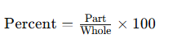
- Use this formula to create the ratios for the grade 6 data and convert it to percentages.

Source | Grade 8
YouTube | 14
TikTok | 10
Google Search | 22
AI Chatbots | 18
Asking Someone | 16
Total | 80

Source | Grade 6 | Grade 7 | Grade 8
YouTube | 32% | 25%
TikTok | 24% | 23%
Google Search | 18% | 25%
AI Chatbots | 6% | 13%
Asking Someone | 20% | 15%

Complete the sentence:

- Grade 8 students are about times as likely to use AI Chatbots first compared to grade 6 students.

- Grade 6 students are about times as likely to use YouTube first compared to Grade 8 students.

A segmented bar graph can be used to visualize percentages within groups. Below is a segmented bar graph for the 7th and 8th grade data. Examine these two and complete the segmented bar for the 6th grade.

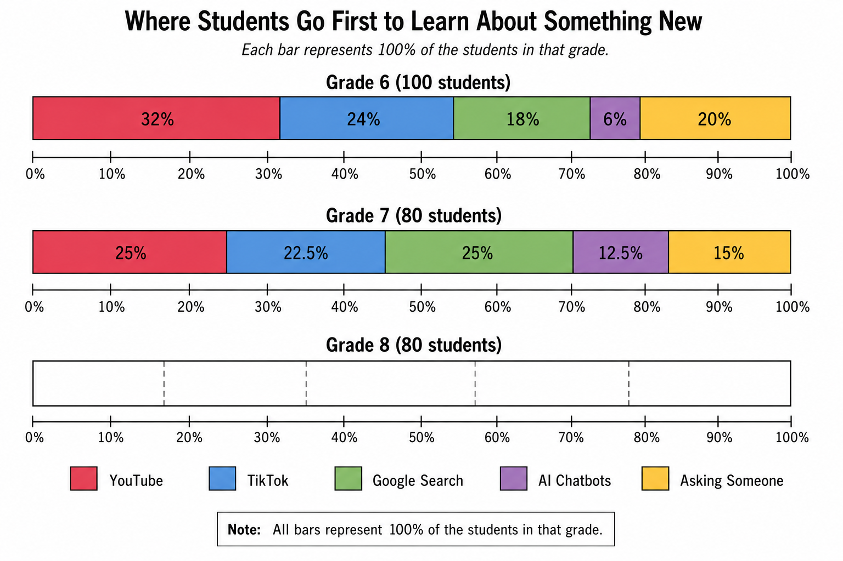

Figure 1. Graph generated using ChatGPT by OpenAI based on data from Pew Research Center.

- Which source becomes MORE popular as grade level increases?

- Which source becomes LESS popular as grade level increases?

- Which source stays the most consistent across all grade levels?

- Why are percentages more useful than row counts here?

- If you know a student is in Grade 8, does that help predict where they are most likely to go first to learn something new? Explain.

- If the segmented bar charts for all grades looked almost identical, what would that suggest?

- Do grade levels and preferred sources of information appear related? Use evidence from the graphs to describe any relationship you identify.

- Why can overall totals sometimes hide important patterns?

- Why are segmented bar charts useful?

- How did ratios and percentages help you make fair comparisons?

Activity 3: Comparing representations

Pew Research conducted a similar study and produced the following graphs:

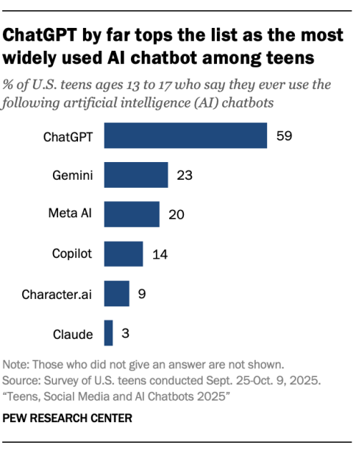
Source: Pew Research Center, Teens, Social Media and AI Chatbots 2025 (2025).

- What do you notice from this bar chart?

.

- If you were to make a segmented bar chart to explore this data further, what additional variable would you select? Explain by writing a question that you could answer if the graph were available for you to explore.

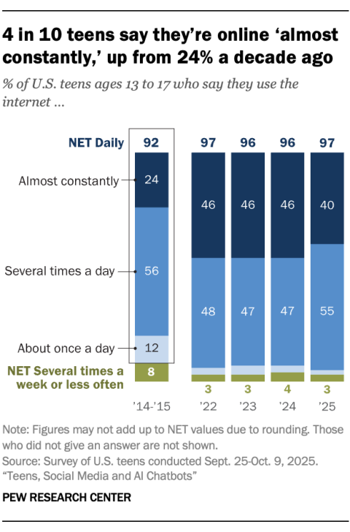
Source: Pew Research Center, Teens, Social Media and AI Chatbots 2025 (2025).

- This segmented bar chart uses time as one of the variables. The headline indicates that the almost constant value has dramatically increased from 24% to 40% over 10 years. What other headline could you write to describe the results in this graph?

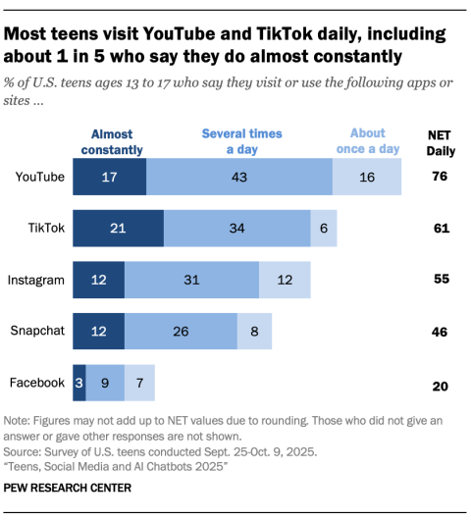
Source: Pew Research Center, Teens, Social Media and AI Chatbots 2025 (2025).

- What is similar and what is different about this segmented bar graph compared to the one you made earlier?

- What information does this graph show that our segmented bar graph does not show?

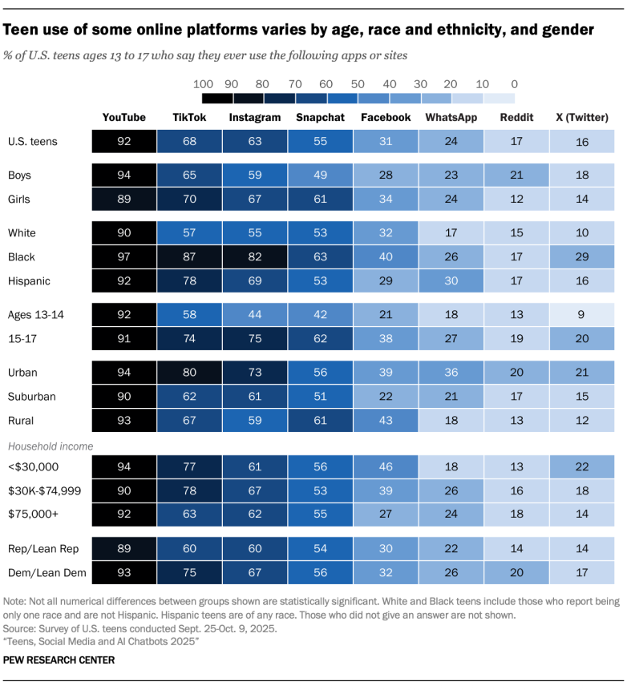

Source: Pew Research Center, Teens, Social Media and AI Chatbots 2025 (2025).

- This graph also displays percentages for making comparisons. How is it different than a segmented bar graph?

- What is one key finding you can make reading this graph?

