PRE-ALG: Scientific Notation Name ________________________
Moon Distances

Warm-up:

There are almost 900 moons in our solar system! On Earth, we only have one, so which planets have the bulk of the moons? Is there a reason certain planets have more moons than others? What would the night sky look like on different planets?

Today, we are going to use NASA data to investigate.

PART 1: Data Exploration using CODAP

Open Moon Data in CODAP.

- Take a moment to make graphs and explore the data by examining the data table and making graphs.

- Find at least three things that are interesting about the relationship between moons and planets.

- Now, group the moons by Planet Type.

- List out at least 1 interesting thing about the moon from each Planet Type:

- Rock
- Ice
- Gas

- Pick one planet that has more than three moons.

- Find out the distance from the planet’s surface to the closest, the middle, and the furthest moon of your moon. How did you calculate the middle?

- Write the distance in standard and scientific notation using 3 significant figures. Fill in the table:

Planet: | Distance to Closest Moon | Distance to Middle Moon | Distance to Furthest Moon
Standard Notation
Scientific Notation

- What would the night sky look like with these three moons from your planet?

Start with a horizontal line to represent your planet’s surface. Figure out a scale factor that allows you to represent all three distances on the same sheet of paper. Be sure to create a key on your drawing.

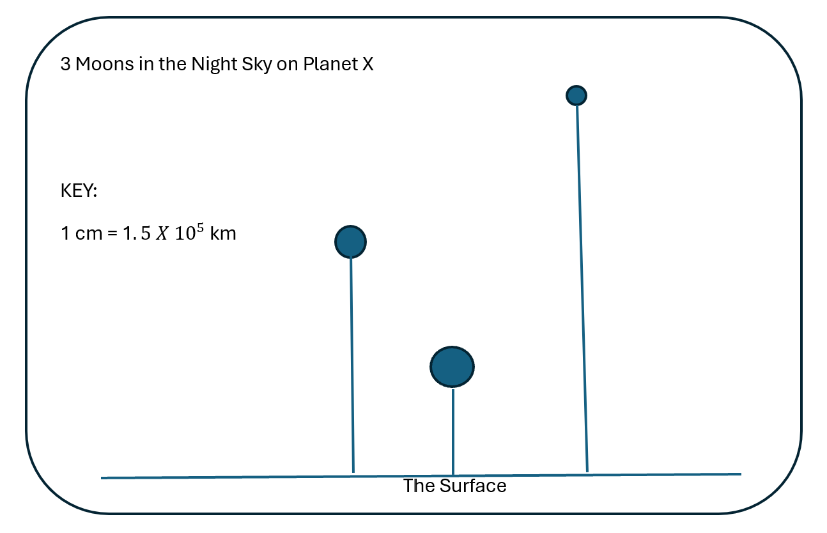

Trade drawings with a partner who has a different planet. Using their map, measure out the distance from the surface to the three moons. Use their scale factor to calculate the actual distance from the planet to the three moons. Check against the values in CODAP to check the precision of the drawing.

