Boom and Bust
Using 90 years of real population data to investigate carrying capacity, limiting factors, and predator-prey dynamics

Name: | Date: | Period:

SECTION 1 -- BACKGROUND

90 years of counting animals

Between 1845 and 1935 the Hudson Bay Company in Canada purchased animal pelts from trappers every year and kept meticulous records. Two of the species they tracked most carefully were the snowshoe hare -- a small rabbit-like mammal that is the primary food source for Canada lynx -- and the Canada lynx itself. The records show something remarkable: both populations rose and fell in dramatic waves, roughly every 9-11 years, for 90 years without stopping.

Today you will load that data into CODAP, graph it, and answer the central question of population ecology: Why do populations never just keep growing?

INTRODUCTION:
Your teacher has shared the statement: “90% of the Hares Are Gone. The Experts Are Not Worried. Why."
Think for a moment and then turn and talk with your partner about why you think this statement is true.
After a minute, we’ll come back together as a class and talk about what your thoughts are.

Q1. Before you look at the data, make a prediction: if snowshoe hares have no predators and unlimited food, what would you expect their population graph to look like over 90 years? Sketch the shape.

Q2. Now predict: if Canada lynx depend almost entirely on snowshoe hares for food, what would you expect the lynx population graph to look like compared to the hare graph?

SECTION 2 -- KEY VOCABULARY

TERM | DEFINITION
Carrying capacity (K) | The maximum population size an environment can sustainably support given available food, space, and other resources
Limiting factor | Any resource or condition that prevents a population from growing without limit
Density-dependent factor | A limiting factor whose effect gets stronger as population density increases (e.g. predation, disease)
Density-independent factor | A limiting factor that affects populations regardless of how dense they are (e.g. a severe winter)
Time lag | The delay between a change in one population and the resulting change in another population
Boom-and-bust cycle | A repeating pattern of rapid population growth followed by rapid population decline

Q3. Give one example of a density-dependent limiting factor and one density-independent limiting factor that might affect a deer population in a forest. Explain why each fits its category.

SECTION 3 -- THE DATASET

The CODAP file contains 91 years of annual population data.

COLUMN | WHAT IT SHOWS
year | The year of measurement (1845-1935)
Snowshoe hare thousands | Estimated snowshoe hare population in thousands
Canada lynx thousands | Estimated Canada lynx population in thousands

Q4. Before graphing the data, look at the raw numbers in the table. Approximately how many hares are there at peak compared to the number of lynx? What does this ratio suggest about the predator-prey relationship?

SECTION 4 -- BUILDING AND READING YOUR GRAPH IN CODAP

STEP | WHAT TO DO | DONE
1 | Open CODAP. https://codap.concord.org/beta#shared=https%3A%2F%2Fcfm-shared.concord.org%2FsXmUrx8T6M7NC9H1KfRM%2Ffile.json | ☐
2 | Read values. Click individual data points to read exact values. Find the year and value of the highest hare peak in the dataset. | ☐
3 | Find the time lag. Find the corresponding lynx peak after the hare peak you identified. Record both years and calculate the lag. | ☐
4 | Count cycles. Count how many complete hare boom-and-bust cycles appear between 1845 and 1935. | ☐

Describe or sketch your graph below:

SECTION 5 -- ANALYSIS QUESTIONS

Q5. Looking at the hare line: the population rises, reaches a maximum, then crashes. What is the approximate maximum value the hare population reaches across most cycles? What ecological term describes this maximum?

Approximate maximum (thousands):

Ecological term for this maximum:

Q6. The hare population does not grow at a steady rate -- it grows faster when it is larger. What type of population growth does this describe? What does the curve look like on your graph during the rising phase of each cycle?

Q7. Identify the year of one hare population peak and the year of the corresponding lynx population peak. Calculate the time lag. What biological explanation accounts for this delay?

Hare peak year:

Lynx peak year:

Time lag (years):

Q8. When the hare population crashes, the lynx population crashes shortly after. Why can't the lynx just switch to eating something else to survive the crash?

Q9. Is predation a density-dependent or density-independent limiting factor in this system? Use specific evidence from your graph to support your answer.

Q10. Look at the hare cycle between 1893 and 1904. Describe what happens to the hare population in three phases: the rising phase, the peak, and the crash. For each phase, describe what is likely happening to the lynx population and explain why.
PHASE | WHAT HAPPENS TO HARE POPULATION | WHAT IS LIKELY HAPPENING TO LYNX -- AND WHY
Rising phase (approx. 1893-1900)
At the peak (approx. 1900-1901)
Crash (approx. 1901-1905)

Q10b. Abiotic factors can also affect hare populations. A severe winter buries vegetation under deep snow, reducing food availability and killing hares directly through cold. How would a severe-winter crash look DIFFERENT on your graph compared to a predator-driven crash? Complete the table below:
 | PREDATOR-DRIVEN CRASH (WHAT YOU SEE IN THE DATA) | SEVERE-WINTER CRASH (WHAT YOU WOULD PREDICT)
What happens to the lynx line at the same time?
How quickly does the hare population fall?
Does the crash happen at a predictable population size?
Does the pattern repeat on a regular cycle?

Q10c. If the snowshoe hare population crashed permanently -- not cyclically, but permanently -- what would likely happen to biodiversity in the boreal forest? Name at least two other species that would be affected and explain whether their populations would increase or decrease and why.

SECTION 6 -- Choice Option

Q11.Use the paper below and choose one option to show what you have learned during this lesson.
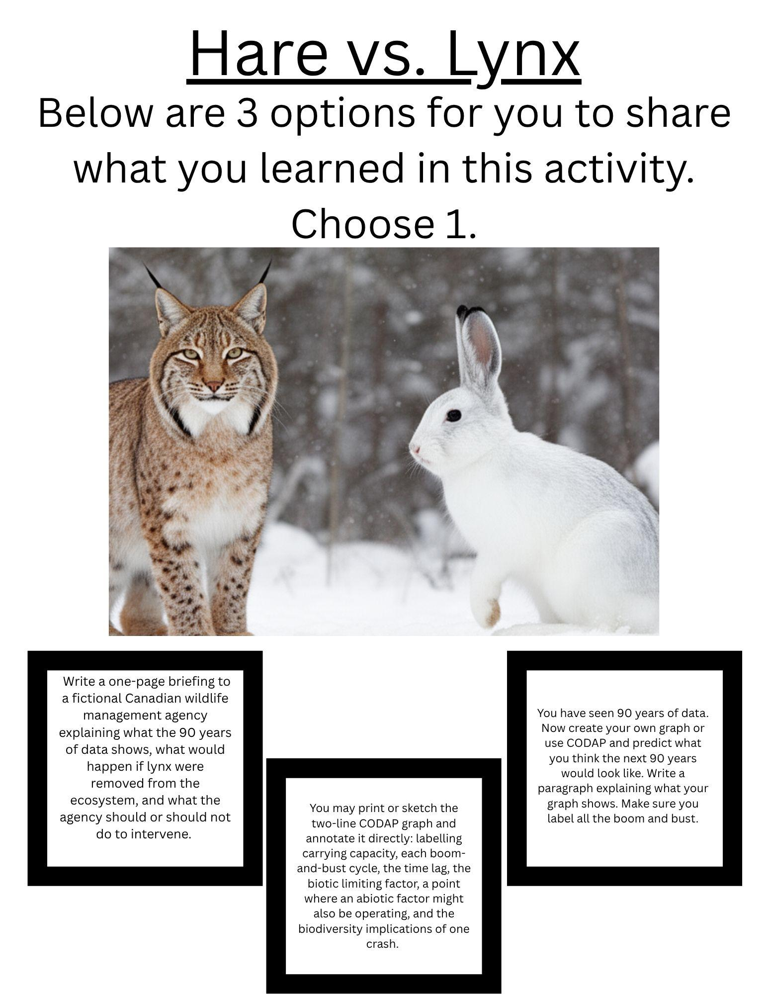

Option 1: The WIldlife Manager’s Report
You are an ecologist writing a one-page briefing for the Canadian Wildlife Management Agency. Your report must address three questions:
1. What does the 90-year dataset show about how the snowshoe hare population is controlled? Identify at least one biotic and one abiotic factor and explain how each works.
2. What would happen to biodiversity in the boreal forest if Canada lynx were permanently removed? Name at least two other species and explain the consequences.
3. Should the agency intervene to stabilise hare populations -- or leave the system alone? Justify your recommendation using evidence from the data.
Format: Written report, 200-300 words. Use specific data from your graph as evidence.

Option 2: The Annotated Graph

Print or carefully sketch your completed two-line CODAP graph. Then annotate it directly on the page by adding the following labels. Each annotation must include a written explanation of 1-2 sentences -- not just a label word.
1. Mark and label the carrying capacity. Explain what sets this limit.
2. Circle one complete boom-and-bust cycle. Label the exponential growth phase and the crash phase.
3. Draw an arrow showing the time lag between one hare peak and the corresponding lynx peak. Write the lag in years and explain why it exists.
4. Mark a point where an abiotic factor might also be affecting the hare population. Describe what evidence would confirm this.
5. Write one sentence in the margin connecting the hare crash to biodiversity -- name at least one other species that would be affected.
Your annotated graph is your final product. Attach it to this worksheet.

Option 3: Prediction and Justification
You have seen 90 years of data. Now create your own graph or use CODAP and predict what you think the next 90 years would look like. Write a paragraph explaining what your graph shows. Make sure you label all the boom and bust.
Task A -- Draw your prediction: Sketch what you predict the hare and lynx population lines will look like from 1935 to 2015. Label the axes. Draw BOTH lines.
Task B -- Justify every feature: Write a paragraph explaining why you drew the lines the way you did. Address: the shape of each cycle, the approximate peak height, the time lag between species, and the number of cycles.
Use the terms carrying capacity, density-dependent, and time lag in Task B.
Claim Evidence Reasoning Option:
THE QUESTION
How do both biotic and abiotic factors affect the snowshoe hare population and biodiversity in the boreal forest? Use evidence from your CODAP graph for the biotic factor and your knowledge of boreal forest ecology for the abiotic factor.

Claim: State how a biotic factor AND an abiotic factor each affect the snowshoe hare population. Name both factors in your claim.

Evidence: Cite specific data from your graph for the biotic factor (years, population values, time lag). For the abiotic factor, describe what the graph would look like differently if an abiotic factor were the primary cause of population change.

Reasoning: Explain the mechanism for both factors. Use the words carrying capacity, density-dependent, density-independent, predation, time lag, and biodiversity in your reasoning.

Data: MacLulich D.A. (1937). Fluctuations in numbers of the varying hare. University of Toronto Studies. · GPDD Version 2, NERC Centre for Population Biology, Imperial College (2010) · NGSS HS-LS2-1, HS-LS2-2

