Lesson Plan:Similar Triangles

Lesson Plan Resource Template
Lesson Overview
Description | In this lesson, students investigate similar right triangles by measuring side lengths and calculating ratios. Through collecting and analyzing data from a variety of triangles, they discover that triangles with the same angle measures have proportional side lengths, leading to consistent ratios. Students test their ideas by grouping and comparing triangles, then extend their findings using tables and graphs to examine how these relationships change as angles vary. The lesson concludes with a real-world application involving height and shadow length, reinforcing similarity as a tool for understanding and modeling proportional relationships.
Subject Area(s) | Mathematics
Grade Band(s) | 6-8

Learning Progression Alignment
Strand | Strand D — Interpreting Problems and Results
Concept | Substrand D.2. — Problem Identification and Question Formation
DSLP | Concept D.2.1 — Verifiable questions and statements — Identify and create the type of questions that can be answered by data, and are eventually verifiable using a combination of modeling and experimentation.  - 6-8.D.2.1a: Ask or identify a question that can be verified with data collected through observations.  - 6-8.D.2.1b: State a guess or potential answer to a question for later verification or testing via a hypothesis.
Common Core | 6.RP.A.3  7.G.A.1  7.RP.A.2  8.G.A.4

Tool(s)
Type | No-Code
Tool | CODAPSpreadsheet
Programming Language
Other Tech Notes

Lesson Materials
Dataset
Datasheet
Student Document(s) & File(s) | Triangle Cards with Ratio Table.pdf  Similar Triangles Student  Similar Triangle CODAP  Student WS
Teacher Document(s) & File(s) | Similar Triangles Teacher  Similar Triangle Teacher CODAP  Teacher WS

Lesson Plan
Lesson Plan
Lesson Focus | In this lesson, students investigate relationships in right triangles by measuring side lengths and angles and using these measurements to calculate and compare ratios. They record and organize their data in a shared table or spreadsheet, looking for patterns and repeated values across different triangles. Students make conjectures about the relationships between side lengths and angles, and test these ideas by grouping and analyzing similar triangles. Using tools such as rulers and protractors, they gather evidence and represent their findings with tables and graphs. As they analyze how ratios change with angle measures, students refine their thinking based on new data and observations. The lesson concludes with an application to a real-world context, such as determining height using shadows, where students explain and justify their reasoning using data and evidence.
Content Objective(s) | Understand and identify similar figures  Recognize that right triangles with the same angle measures are similar.  Use ratios to describe relationships between quantities  Compute and interpret ratios of side lengths within triangles.  Understand proportional relationships  Recognize that corresponding side lengths in similar triangles are proportional.  Compare ratios across multiple representations  Use tables and graphs to identify and analyze consistent ratios.  Analyze patterns and make generalizations  Identify repeated ratio values and develop conjectures about why they occur.  Use measurement tools accurately  Measure angles and side lengths using protractors and rulers.  Represent and interpret data  Organize data in tables and use graphs to explore relationships between variables.  Apply proportional reasoning in a real-world context  Use similar triangles to reason about height and shadow relationships.
Prerequisite Knowledge & Skills | Understanding of ratios  Students should be able to form and interpret ratios (e.g., comparing two side lengths).  Basic proportional reasoning  Students should recognize that equivalent ratios represent the same relationship, even if they are not yet fluent in solving proportion equations.  Multiplication and division with whole numbers and decimals  Needed to compute and compare ratios accurately.  Familiarity with fractions and decimals  Students should be able to express ratios as fractions and convert them to decimal form (with or without a calculator).  Measuring with a ruler  Students should be able to measure lengths to a reasonable degree of accuracy.  Measuring angles with a protractor  Students should be able to measure and identify angle measures in degrees.  Basic data organization skills  Students should be able to record values in a table and look for patterns.
Lesson Details
Lesson Hook & Warm-up  5 mins | STUDENT FACING  True or False: For every person in this room, if we were to go outside right now, the ratio of your height to your shadow is the same. (Height/Shadow Length)
Lesson Hook & Warm-up  5 mins | TEACHER FACING  Engage students with a debate by posing the above question to them. Begin by having students think to themselves for 1 minute, then talk to a partner or group members for 1 minute. Ask students to raise their hands if they believe it is true.  Do not answer the question but instead indicate that this is what we will be investigating today.
Activity 1  20-25 mins | STUDENT FACING  Student WS
Activity 1  20-25 mins | TEACHER FACING  Activity 1: Generating Data and Conjectures  Explain to students that each student will receive a unique right triangle with different side lengths and will compute three ratios for that triangle using the indicated reference angle (bottom right): (It may be helpful to emphasize that each triangle has different side lengths by showing students a few examples before handing them out or asking students to look at their peers triangles if they are seated in groups.)  - opposite side to hypotenuse  - adjacent side to hypotenuse  - opposite side to adjacent side  Students should first write each ratio as a fraction in the space provided, then use a calculator to find a decimal approximation, rounded to the nearest hundredth.  Once the ratios have been calculated, students will enter their values into a shared spreadsheet. Students should enter their name (not the triangle number) along with their three ratio values.  A completed version of the spreadsheet can be found here:  Similar Triangles  The student version can be found here: Similar Triangles Student.  Sample spreadsheet with sorted data:  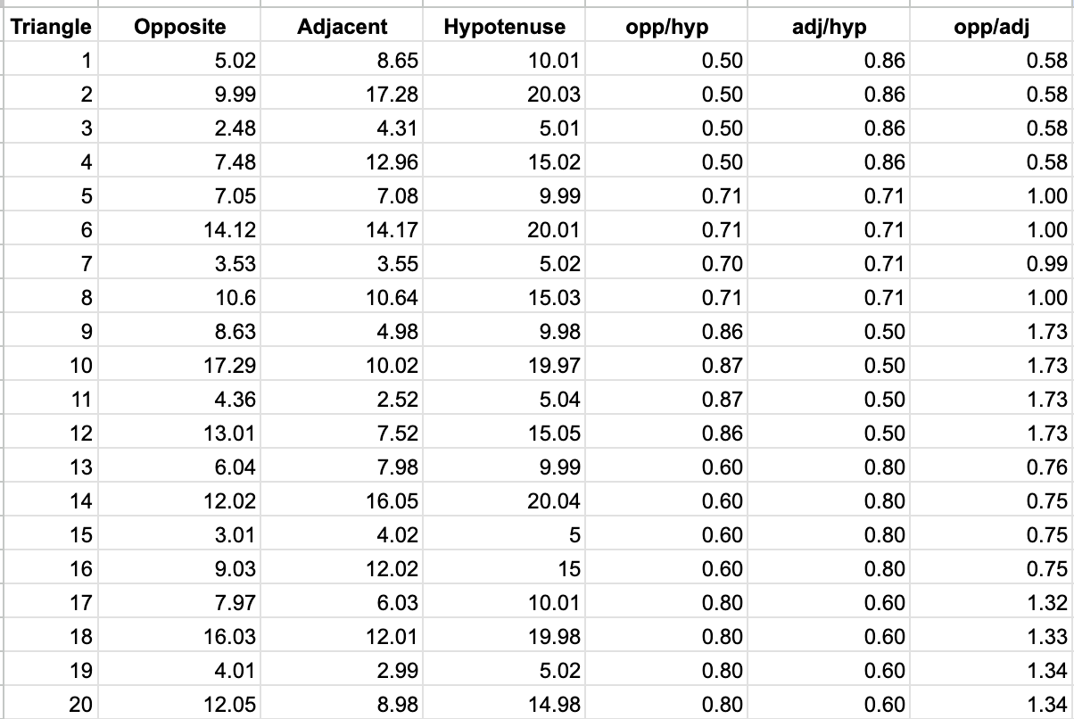  After all data has been entered, ask:  “What do you notice?”  Allow students time to observe quietly before sharing. Students should begin to see that many of the ratio values repeat. To make this more visible, the teacher can sort the spreadsheet by one of the ratio columns, revealing clusters of identical (or nearly identical) values.  Optional connection: Organizing data in a spreadsheet helps reveal patterns that may not be immediately visible.  Press further:  “Why might completely different triangles produce the same ratios?”  Record student ideas without evaluating them. Encourage students to build on one another’s thinking.  If needed, gently extend the conversation:  “What would have to be the same about two triangles for all three ratios to match?”  Do not resolve this question—students will test these ideas in the next activity.
Activity 2  20-25 mins | STUDENT FACING
Activity 2  20-25 mins | TEACHER FACING  Activity 2: Pattern recognition and group investigation  Ask students to test their conjectures by grouping themselves with others who obtained matching (or nearly matching) ratio values.  Once students are in groups, have them investigate the conjectures from Activity 1. Provide tools such as rulers and protractors so they can examine both side lengths and angle measures.  Frame the work clearly:  “Your goal is not just to check a conjecture, but to gather evidence.  “What can you measure that supports or contradicts the idea?”  Students should be prepared to explain:  - what they tested  - what they observed  - what conclusion they reached  Bring the class together for discussion. Invite each group to present one conjecture and the evidence they found.  As groups share, record key observations publicly. Allow patterns across groups to emerge naturally.  As the discussion develops—especially if attention turns toward angle measures—pause and consolidate:  “What seems to be true across all of these triangles?”  Compile relevant information into a shared table (similar to the second tab of the spreadsheet). This will serve as a reference point for the next activity.  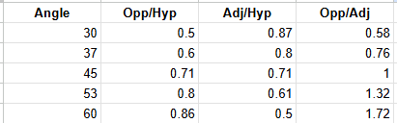
Activity 3  35-45 mins | STUDENT FACING
Activity 3  35-45 mins | TEACHER FACING  Activity 3: Creating a model  Direct students’ attention to the current table, which contains only a limited number of entries.  Ask:  “If we kept going, what would a complete table look like?”  Encourage students to think about:  - what values are possible for the angle  - how the ratios might behave  - whether there are limits to these values  Keep the discussion open-ended. Record conjectures, but do not confirm or refine them yet.  Next, have students open a new document in CODAP and import the current table.  Before graphing, ask:  “What do you expect the graphs to look like?”  Students can briefly sketch or describe predictions.  Then allow time for exploration:  - create graphs  - compare relationships between angle and each ratio  - look for patterns or trends  Afterward, ask:  “Do you want to revise or add to any of your conjectures?”  Sample graphs:  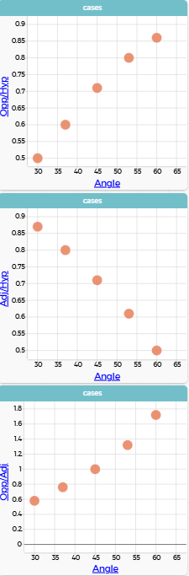  Similar Triangles Activity 2  Now extend the dataset.  Assign each student a specific angle measure so that, collectively, the class spans angles from 0° to 90°.  On the back of their worksheet, students should:  - draw a right triangle using their assigned angle  - calculate the three ratios  - repeat for the other acute angle in the triangle  This will produce two rows of data per student.  Students should then:  - add their data to the shared table  - re-import the updated dataset into CODAP  - continue exploring the patterns  Note: A completed table is available on Sheet 3 of the spreadsheet.  Sample graphs:  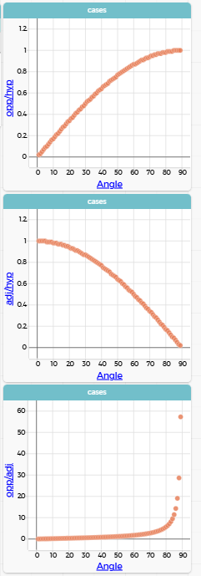  Similar Triangles Activity 3  Bring the class back together to revisit earlier conjectures:  “What do we now have evidence for?”  “What needs to be revised?”  Require students to support their reasoning using their data and graphs.  Press one step further:  “Why do these patterns occur?”  A detailed answer to this does not need to be provided, the conversation is more important. For the ratios involving the hypotenuse, students may recognize that the hypotenuse is always the longest side, which constrains the ratio to values less than or equal to 1. As the angle increases, the opposite side grows (or the adjacent shrinks), causing the ratio to approach 1 but never exceed it.  For the ratio of opposite to adjacent, students may notice that this constraint no longer exists. As the angle increases, the adjacent side becomes very small, causing the ratio to grow rapidly. Because there is no fixed upper bound, the values can become very large.
Closure  5 minutes | Purpose:  Students synthesize their work by connecting their observations about ratios and graphs to the original context of shadows, and articulate the key idea that angle determines the relationship between side lengths in right triangles.  Step 1: Revisit the Original Question  Return to the opening prompt:  “At the start of class, we asked:  If we went outside right now, would everyone have the same height-to-shadow ratio?”  Give students a brief think time (30 seconds), then have them turn and talk with a partner.  Step 2: Press for Precision  Bring the class back together and ask:  - Is this always true, or does it depend on something?  Guide students to articulate that the ratio depends on the angle of the sun.  Look for responses such as:  - “It would be the same if the sun angle is the same”  - “It depends on the time of day”  Step 3: Connect to the Mathematics  Make the connection explicit:  “What you are saying is that the ratio between the sides of the triangle depends on the angle.”  Connect this directly to their work:  “This is what you observed in your data and graphs—triangles with the same angle produced the same ratios, even when the triangles were different sizes.”  Step 4: Extend the Idea  Ask:  - What would happen if we measured shadows later in the day?  - What is changing in the triangle?  Guide students to recognize that:  - the angle changes, which causes the ratios to change  - the triangle’s shape (angle), not just its size, determines the relationship  Step 5: Synthesize the Key Idea  Close by clearly naming the learning:  “Today, students discovered that in right triangles, the angle determines the relationship between the side lengths. Because of this, triangles can be used to model real-world situations like shadows, heights, and distances.”  Key Idea to Highlight  The ratios of side lengths in right triangles are determined by the angle, not the size of the triangle.
Student Follow Up & Practice  15-20 min  Extension: 10-15 min | Return to the original question about height and shadow.  If possible, take students outside to measure their height and the length of their shadow. Students should compute the ratio of height to shadow length. The values should be similar, with small differences due to measurement error.  Back in the classroom, revisit the table of ratios and angle measures. Ask:  “What additional information can this table give us?”  Students should recognize that their ratio corresponds to an angle in the table. Give them time to interpret what that angle represents.  With guidance, they can arrive at the idea that this angle describes the position of the sun at that moment.  Extend the thinking:  “What would happen if we repeated this tomorrow at the same time?”  “What if we did this at a different time of day?”  Encourage students to reason:  - shorter shadows → what must be true about the angle?  - longer shadows → how does the angle change?  If possible, collect additional data on another day or time to test these ideas.  Extension: Shadows Throughout the Day  Ask students to consider how shadow length changes over an entire day and connect this to their graphs.  “What happens to a shadow as the sun rises? When it is highest? When it sets?”  Encourage qualitative reasoning first.  Then connect to their graphs:  “Where do you see this behavior in your data?”  “Which ratio best captures this change?”  Finally, extend the model:  “Could we represent the entire day on our graph?”  “What happens as the angle continues to change?”  Students should begin to see their graphs not just as discrete points, but as part of a continuous relationship.  This sets the foundation for future work with trigonometric functions, without needing to formally name them yet.
References

