What Does It Mean to Be American?

Read the excerpt from the transcript of Opinion | A Conversation With Native Americans on Race - The New York Times

Native Americans challenge their invisibility in society.
"We’re treated like animals. They monitor our blood quantum. I mean, besides dogs and horses, I don’t know of any other animal that they monitor the blood quantum. The way I explain it to people is, imagine a pizza with different slices, and let’s say 32 slices. Of the 32 slices, I’m 28 Apache. That’s my particular blood quantum. And Native Americans in the U.S. are the only minority group who have to prove their nativeness on an Indian card. It’s used to divide native people against each other, because it can be used as a way to say, I am more native than you. And I was a part of that, too. I used my 4 fourths to kind of make myself feel better against other people. The one drop rule, meaning that one drop of black blood makes you black, that was to keep as many people oppressed or legitimize their oppression as possible. But on the other side, one drop of anything else completely dilutes you as a native person. So if you’re a native person, you have the one drop of something else, then suddenly you’re less native. So it’s the opposite. Traditionally, within the Apache society, you go by the mother." (transcript)

- Underline references to identity, belonging, or citizenship.

- Circle references to systems, rules, measurements, or government authority.

- Place a star (*) beside statements that challenge those systems.

- How might the speaker's experiences influence their perspective on blood quantum?

Read the excerpt from the Indian Reorganization Act (1934)
An Act of June 18, 1934, Public Law 73-383, 48 STAT 984, to Conserve and Develop Indian Lands and Resources; To Extend to Indians the Right to Form Business and other Organizations; To Establish a Credit System for Indians; To Grant Certain Rights of Home Rule to Indians; To Provide for Vocational Education for Indians; and for Other Purposes
SEC. 19. The term "Indian" as used in this Act shall include all persons of Indian descent who are members of any recognized Indian tribe now under Federal jurisdiction, and all persons who are descendants of such members who were, on June 1, 1934, residing within the present boundaries of any Indian reservation, and shall further include all other persons of one-half or more Indian blood. For the purposes of this Act, Eskimos and other aboriginal peoples of Alaska shall be considered Indians. The term "tribe" wherever used in this Act shall be construed to refer to any Indian tribe. organized band, pueblo, or the Indians residing on one reservation. The words "adult Indians" wherever used in this Act shall be construed to refer to Indians who have attained the age of twenty-one years.
Defines “Indian” as including persons of Indian descent and those with “one-half or more Indian blood.”

- Underline words or phrases that define who is considered "Indian."

- Circle words or phrases that show evidence used to determine identity

- Star (*) statements where the government is making a decision about belonging.

- How does this law define identity differently from the Native perspective in the transcript excerpt?

Language & Traditions (Global Data)
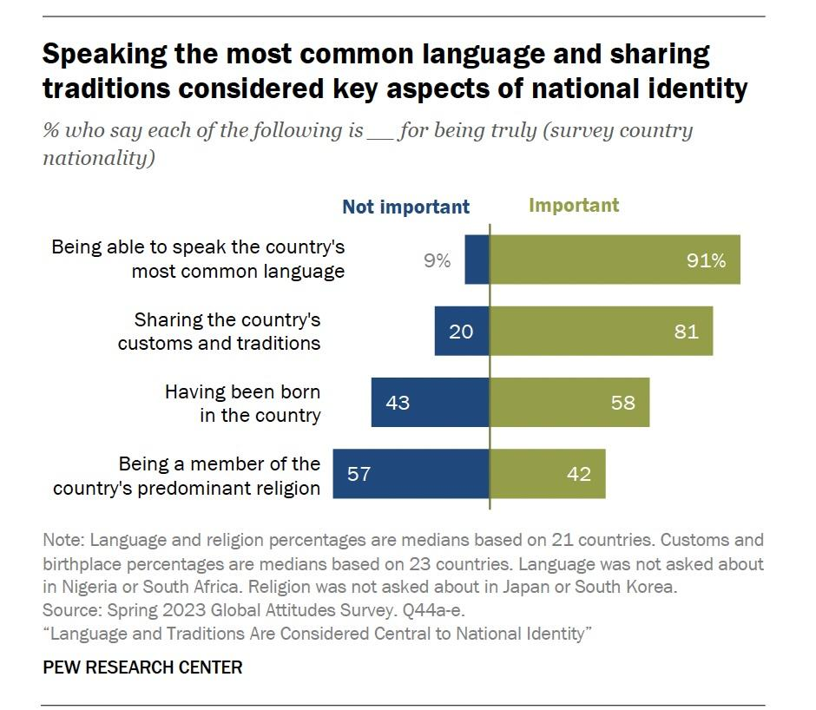

Birthplace & Religion
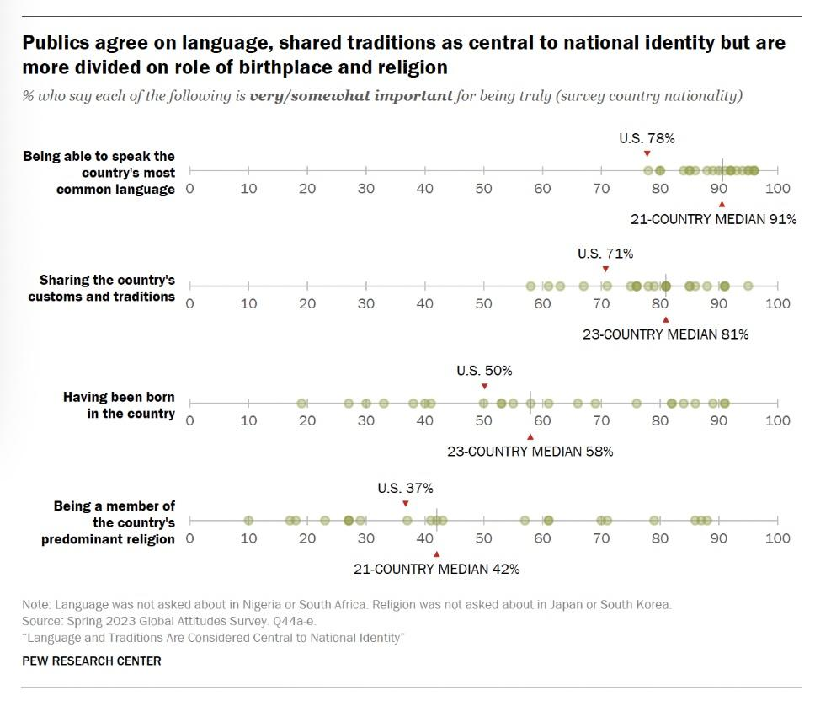

Examine the two Pew visualizations Speaking the Most Common Language and Sharing Traditions Considered Key Aspects of National Identity and Publics Agree on Language and Traditions but Are More Divided on Birthplace and Religion.
Then record:
- Patterns you notice across both visualizations

- One surprising finding

- Two questions that the data raises about national identity or belonging.

Final Reflection Prompt
Using evidence from the Native perspective, the Indian Reorganization Act, and the Pew survey data, write a short response that answers:
What does it mean to be American, and who gets to decide?
Your response should:
- Make a claim.
- Use evidence from at least two sources.
- Explain how different groups may define belonging differently.

