Attention History
Compelling question: What has changed and what has remained the same in the ways organizations compete for human attention?

In 1833, most newspapers cost about 6 cents.
Benjamin Day decided to sell his newspaper for only 1 cent.
Many people believed this was a poor business decision because newspapers were expensive to print.
Yet Day's newspaper became one of the most successful newspapers in the United States.
Questions
How could a newspaper that charged less money become more successful?

If a newspaper is not making much money from readers, where else might it get revenue?
Activity 1: Investigating Historical Media
Today you will examine two historical sources and investigate how media organizations attracted audiences before the internet and social media.
Source 1: Yes, Virginia, There Is a Santa Claus (1897)
Read the source description, Virginia's letter, and the newspaper editorial.
- What does Virginia's statement in her letter suggest about the role newspapers played in American society?

Source 2: Gunsmoke Radio Broadcast (1952)
Read the source description and the excerpt from the Gunsmoke transcript.
- Why might listeners want to hear the next episode?

- Why does the announcer specifically tell listeners to "join us again next week"?

Activity 2: Introducing the Attention Merchant

Key Term
Attention Merchant: A business that profits by attracting people's attention and selling access to audiences.
Historian Tim Wu argues that many media companies compete for human attention.
Timeline Activity
Review the timeline and complete the final two rows.
Date | Medium | What changed?
1897 | Newspapers | Mass audiences and trust
1952 | Radio | Attention held through entertainment
1950s-1990s | TV | Visual media enters the home
2000s | Internet
2010s - | Social Media | \

- Based on what you know about Google and TikTok, how would you complete the final two rows?
2000s Internet

2010s–Present Social Media

- Even though the methods changed, what remained the same over time across newspapers, radio, television, internet advertising, and social media?

Activity 3: Investigating Attention Today
Examine the three visualizations from the Pew Research Center report How Teens and Parents Approach Screen Time.

Visualization 1: Feelings When Without a Smartphone

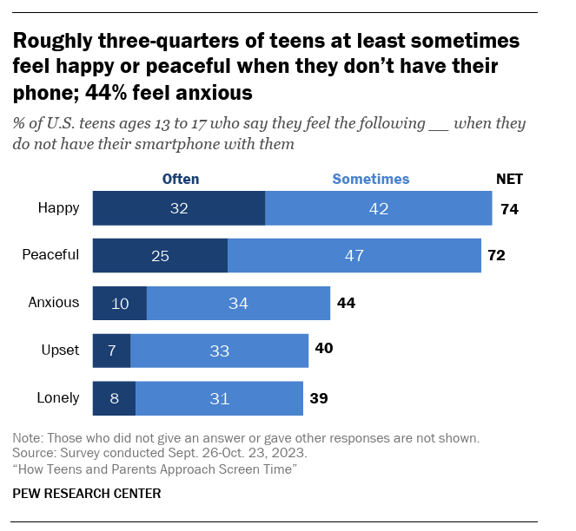
Figure 1. How teens feel when they do not have access to their smartphone. Source: Pew Research Center (2024).
- What patterns do you notice in the data?

- Which finding provides the strongest evidence that smartphones influence attention? Explain.

Visualization 2: Benefits vs. Harms of Smartphones

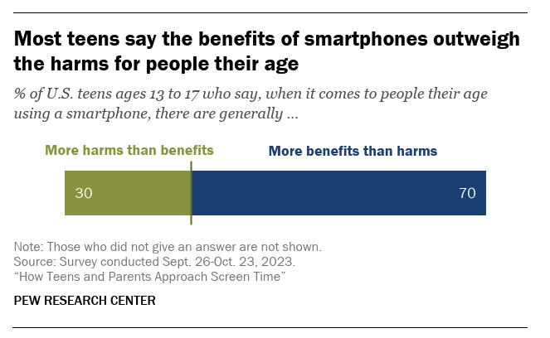
Figure 2. Teen perceptions of smartphone benefits and harms. Source: Pew Research Center (2024).
- Do these findings support or challenge the idea that smartphones have become too influential in people's lives? Explain.

Visualization 3: Impact on Different Areas of Life
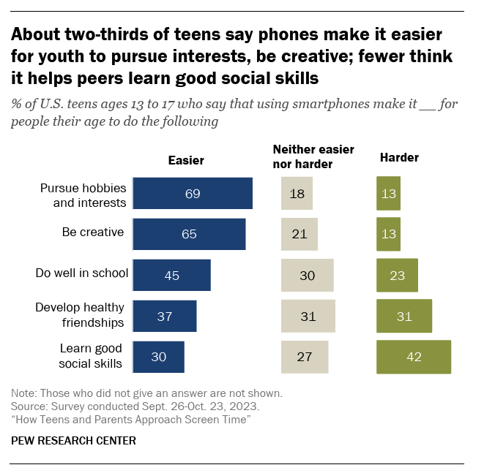
Figure 3. Areas of life that teens believe smartphones improve or make more difficult. Source: Pew Research Center (2024).
- What areas of life do teens believe smartphones improve?

- What areas of life do teens believe smartphones make more difficult?

- What does this suggest about how smartphones influence people's lives?

- After examining the historical sources and the Pew Research Center data, what has changed and what has remained the same in the ways organizations compete for human attention?
What Changed?

What Remained the Same?

Public Service Announcement (PSA)
Create a public service announcement (PSA) that helps people understand how organizations compete for attention and what strategies individuals can use to manage their attention.
Requirements
Your PSA must:
- Reference at least one historical source.
- Reference at least one finding from the Pew Research Center survey.
- Explain one way competition for attention has changed.
- Explain one way competition for attention has remained the same.
- Include a recommendation for how individuals can better manage their attention.

PSA Planning Organizer
Historical source I will use:

Pew finding I will use:

One way competition for attention has changed:

One way competition for attention has remained the same:

My PSA message:

